Homework 4: Smart materials

1. Which one of the following smart materials does not react to electricity? [1]
⬨ Shape memory alloy
⬨ Quantum tunnelling compound
⬨ Thermochromic pigment
⬨ Piezoelectric material

2. Which smart material can be both a conductor and an insulator? [1]

3. Explain one disadvantage of using photochromic particles with
self-darkening glasses. [2]
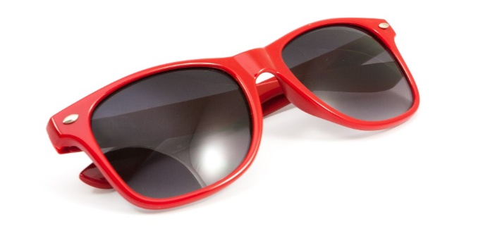

4. Describe how self-healing polymers could be useful in the construction of
plastic frames for glasses and sunglasses. [2]

5. Use the following key words to create a short paragraph that explains the process that self-healing concrete undergoes when activated. [3]
Water – bacteria – stress – calcium carbonate – spheres – food – cracks

6. The following question is about the shape memory alloy, nitinol.
(a) Nitinol is an alloy of nickel and which other metal? [1]

(b) How is a shape ‘set’ in to the memory of nitinol? [2]

(c) A piece of Nitinol has a shape ‘set’ in its memory.
Explain what stimulus is required to return the material to its ‘set’ shape,
once deformed. [1]

(d) Name and briefly describe one commercial use of nitinol. [2]

Total 15 marks

