Homework 5: Composite materials

1. Which one of the following is a type of Aramid fibre? [1]
⬨ Cotton
⬨ Stainless steel thread
⬨ Gore-Tex®
⬨ Kevlar®

2. What is meant by a ‘composite’ material? [2]

3. Put the following steps, for forming a single layer glass reinforced plastic component, in the correct order. Draw lines between the steps. [8]
Step 1 |  | Apply resin and work evenly into matting
Step 2 |  | Clamp in position and leave to cure
Step 3 |  | Apply GRP matting
Step 4 |  | Trim and finish workpiece
Step 5 |  | Prepare mould
Step 6 |  | Apply gel coat
Step 7 |  | Apply release agent
Step 8 |  | Release the workpiece from the mould

4. Explain how a Gore-Tex® membrane works. [3]

5. Gasses, liquids and solids can be microencapsulated in a fabric.

Give two applications of microencapsulation within a technical textile [2]

6. Discuss the environmental concerns regarding microfibre products such as the
cleaning glove shown below. [4]

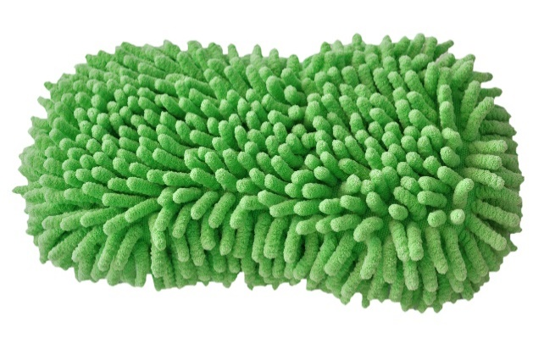

Total 20 marks

