MATHEMATICS

**Higher**

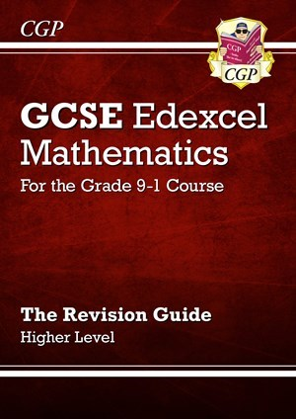

CPG Edexcel mathematics (Higher)

ISBN: 9781782944041

£2.85

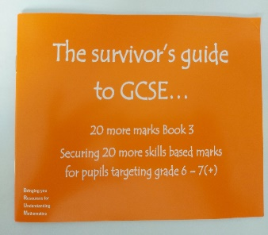

20 More Marks book 3 – Targets grade 6-7+ (orange)

£1.25

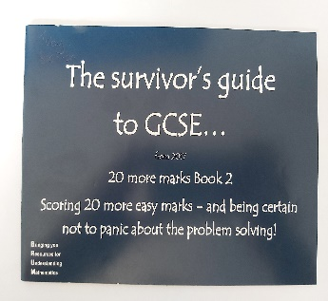

20 More Marks book 2 – Targets grade 5-6 (dark blue)

£1.25

£2.85

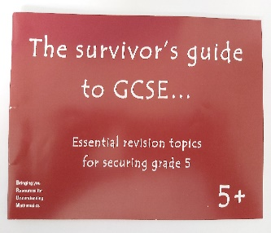

The survivor’s guide to GCSE target 5+ (Red)

£1.25

£2.85

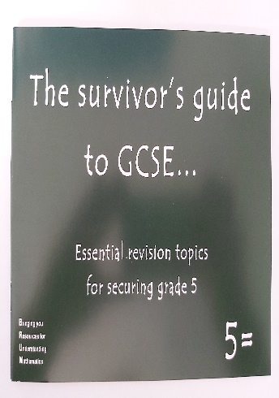

Essential revision topics Book (5=) Building knowledge at grade 5 (dark green)

£1.25

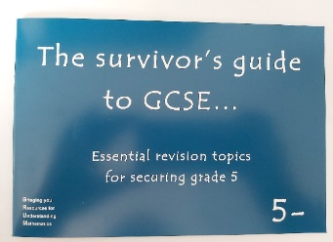

Essential revision topics (5-) Building understanding towards grade 5 (Light blue)

£1.25

Collins GCSE 9-1 Revision - New Edexcel GCSE 9-1 Maths higher Revision Flashcards

£4

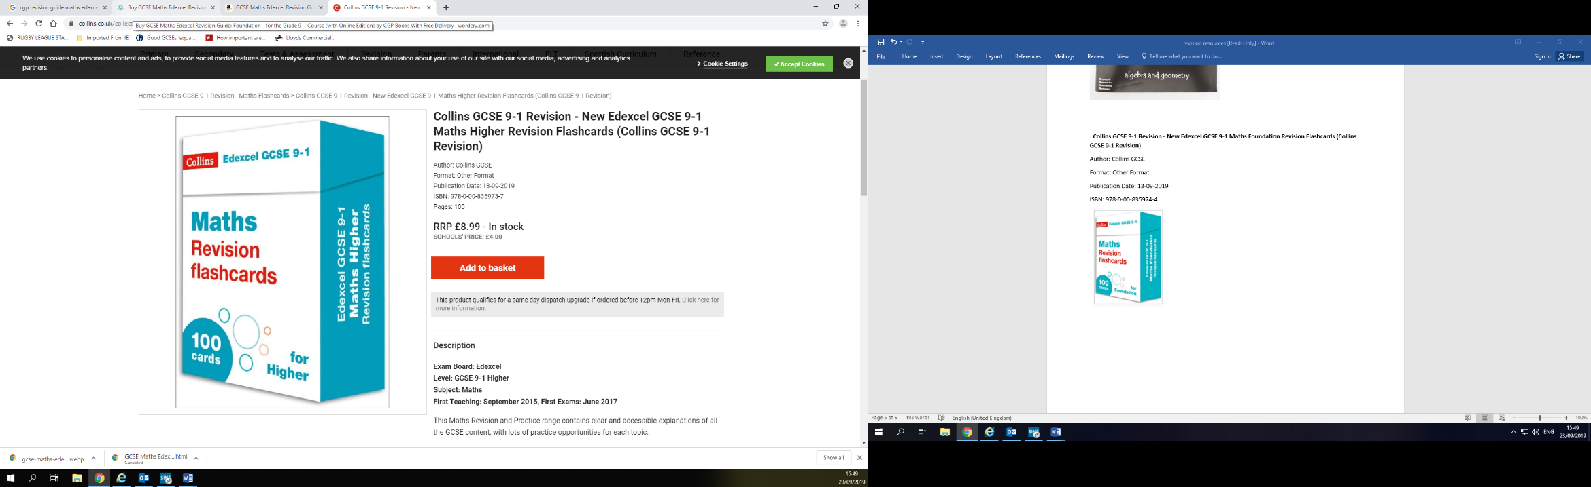

**Foundation**

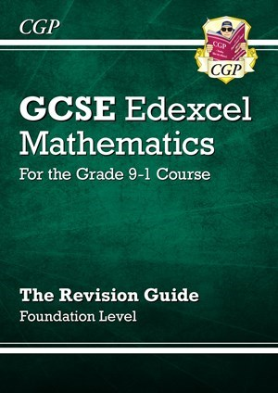

CPG Edexcel mathematics (Foundation)

Product code: MXFR46

ISBN: 9781782944003

£2.85

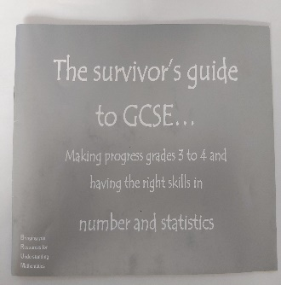

Making progress grades 3-4: Number and statistics (silver)

£1.25

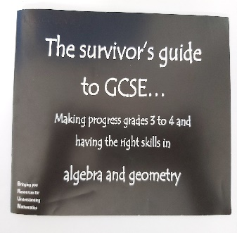

Making progress grades 3-4: Algebra and geometry (black)

£1.25

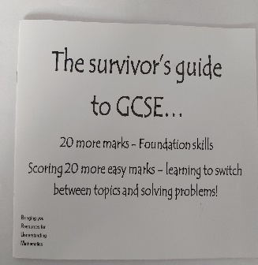

20 More marks book Foundation skills – Targets 3-4 (White)

£1.25

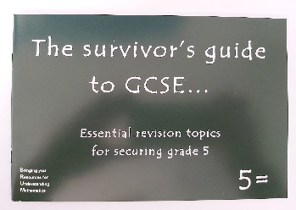

Essential revision topics Book (5=) Building knowledge at grade 5 (dark green)

£1.25

20 More Marks book 1 – Target grade 4-5 (purple)

£1.25

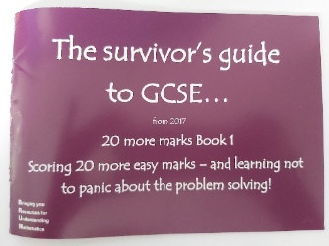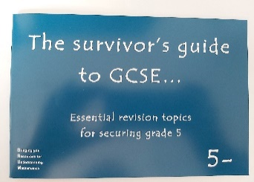

Essential revision topics (5-) Building understanding towards grade 5 (Light blue)

£1.25

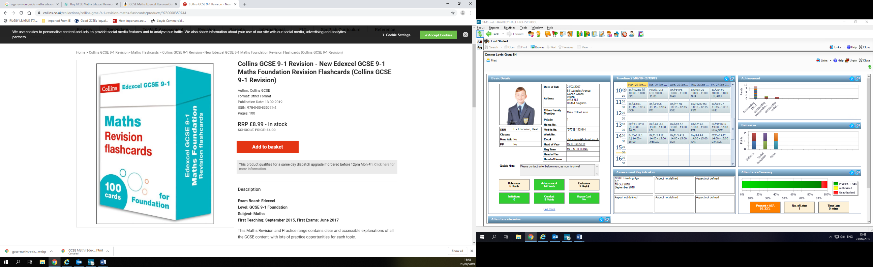

Collins GCSE 9-1 Revision - New Edexcel GCSE 9-1 Maths Foundation Revision Flashcards

£4

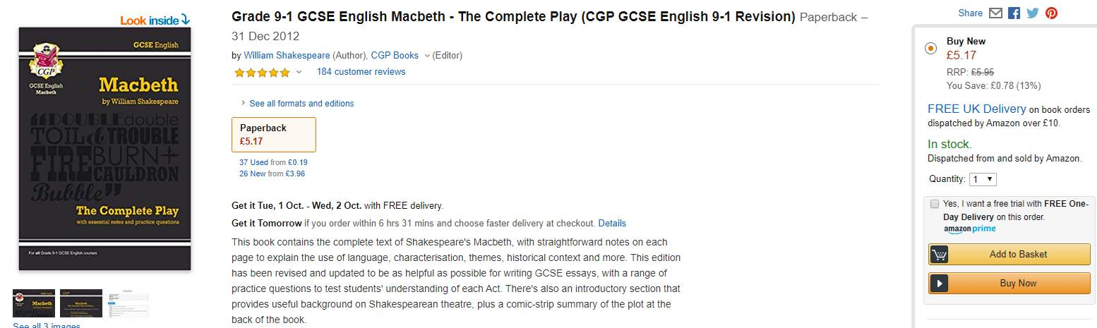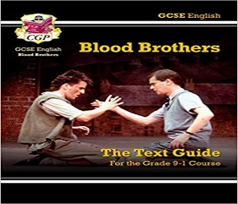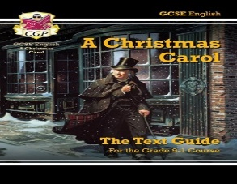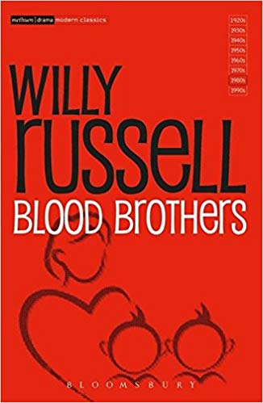E**NGLISH**

A Christmas Carol CGP Text Guide Grade 9-1

(Optional)

£5.95

Blood Brothers CGP Text Guide Grade 9-1

(Optional)

£5.95

CGP Macbeth – the complete play Grade 9-1 ISBN 978-1841461205

Usually bought in Y10

£5.95

A Christmas Carol, Charles Dickens - Wordsworth Classics ISBN 978-840227567

Please purchase own copy

Blood Brothers, Willy Russell –Methuen Student Edition ISBN 978-0413695109

Please purchase own copy

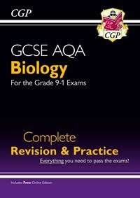SCIENCE

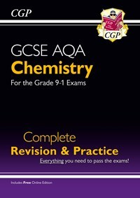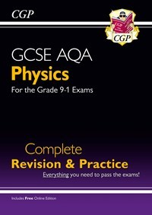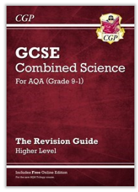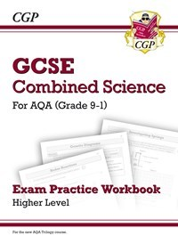

Grade 9-1 GCSE Biology AQA Complete revision guide and practice

ISBN: 9781782945833

£5.50

Grade 9-1 GCSE Chemistry AQA Complete revision guide and practice

ISBN: 9781782945840

£5.50

Grade 9-1 GCSE Physics AQA Complete revision guide and practice

ISBN: 9781782945857

£5.50

CGP Grade 9-1 GCSE Combined Science: AQA revision guide: Higher tier

ISBN: 9781782945598

£5.60

Grade 9-1 GCSE Combined Science: AQA Exam Practice Workbook - Higher

ISBN: 9781782944850

£5.60

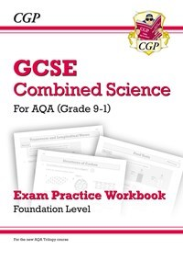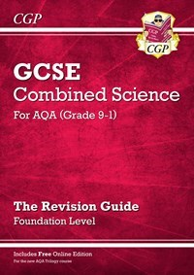

Grade 9-1 GCSE Combined Science: AQA Exam Practice Workbook Foundation

ISBN: 9781782944867

£5.60

Grade 9-1 GCSE Combined Science: AQA revision guide Foundation Tier

ISBN: 9781782945604

£5.60

DESIGN TECHNOLOGY ENGINEERING

My Revision Notes: AQA GCSE (9-1) Design and Technology: All Material Categories and Systems

ISBN: 9781510432314

£9.99

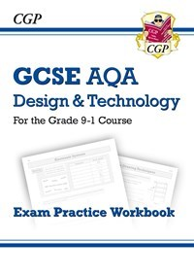

New Grade 9-1 GCSE Design & Technology AQA Exam Practice Workbook

ISBN: 978782947530

£2.85

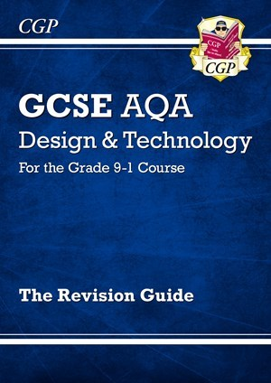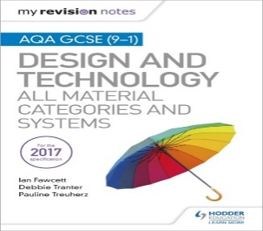

New Grade 9-1 GCSE Design & Technology AQA Revision Guide (CGP GCSE D&T 9-1 Revision)

ISBN: 978-1782947523

£2.85

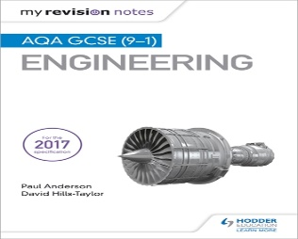

My Revision Notes: AQA GCSE (9-1) Engineering  
ISBN: 9781510425729

£9.99

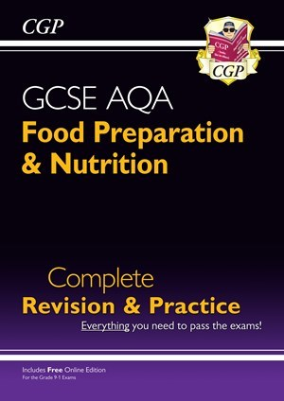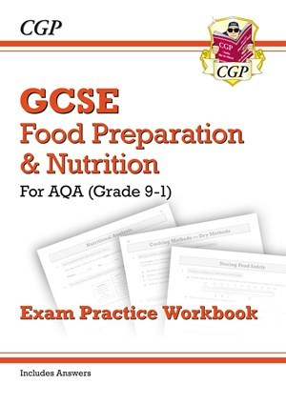COMPUTER SCIENCE FOOD PREPERATION AND NUTRITION

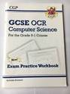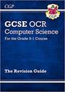

GCSE Food preparation and Nutrition – Complete revision practice Grade 9-1

ISBN: 9781782946502

£5.50

GCSE Food preparation and Nutrition – exam practice Grade 9-1

ISBN: 9781782946502

£2.85

GCSE Computer Science OCR Exam Practice Workbook - for the Grade 9-1

ISBN: 9781782946038

£2.85

Computer science is the CGP revision book and workbook for OCR

ISBN: 9781782946021

£2.85

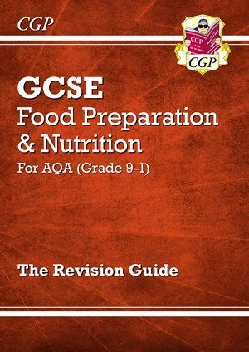

[Grade 9-1 GCSE Food Preparation & Nutrition - AQA Revision Guide (Online Edition)](https://www.cgpbooks.co.uk/secondary-books/gcse/design-technology/food-prep-nutrition/fnar41d-grade-9-1-gcse-food-preparation-nutrit)

£2.85

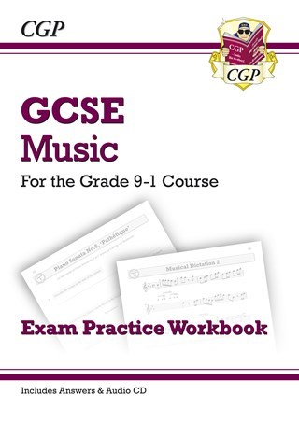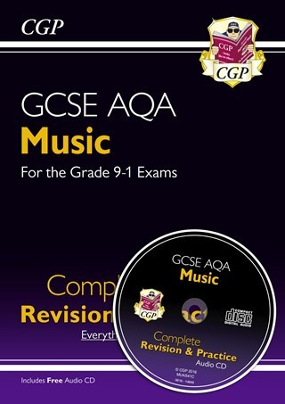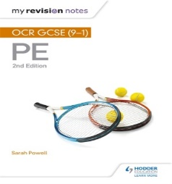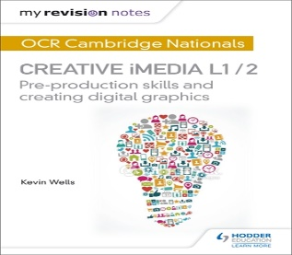CREATIVE IMEDIA PHYSICAL EDUCATION MUSIC

CGP GCSE AQA Music – Complete Revision and Practice.

£7.50

My Revision Notes: OCR Cambridge Nationals in Creative iMedia L 1 / 2: Pre-production skills and Creating digital graphics £9.99

My Revision Notes: OCR GCSE (9-1) PE 2nd Edition  
ISBN: 9781510405257

£9.99

CGP GCSE AQA Music – Complete Revision and Practice.

£7.50

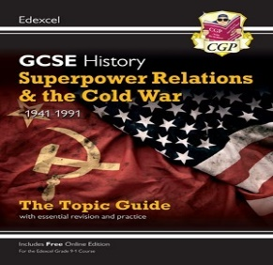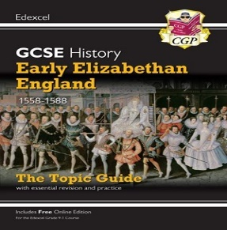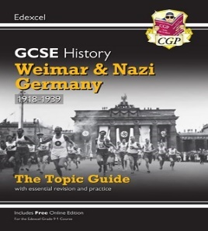HISTORY

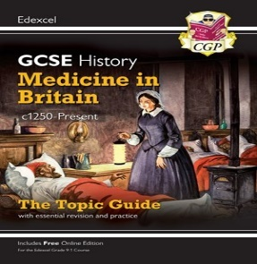

Superpower Relations and the Cold War, 1941-91 ISBN: 9781789082883

£2.75

Early Elizabethan England, c1588-88 ISBN: 9781789082906

£2.75

Weimar and Nazi Germany, 1918-39 ISBN: 9781789082876

£2.75

Medicine in Britain c1250-present day ISBN: 9781789082890

£2.75

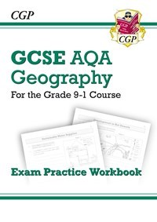GEOGRAPHY SPANISH

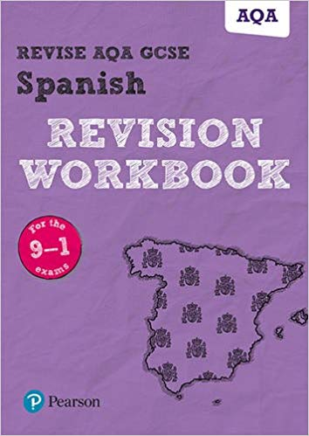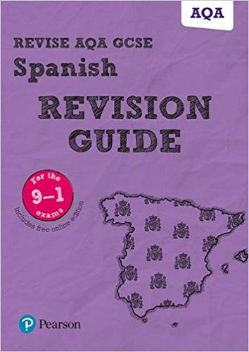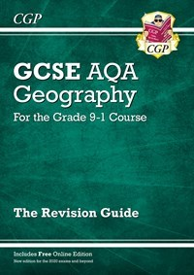

Grade 9-1 GCSE Geography AQA Exam Practice Workbook

£3.25

Grade 9-1 GCSE Geography AQA Exam Practice Workbook

£3.25

Grade 9-1 GCSE Geography AQA Exam Practice Workbook

£3.25

[New GCSE 9-1 Geography AQA Revision Guide](https://www.cgpbooks.co.uk/secondary-books/gcse/humanities/geography/gar45-new-gcse-9-1-geography-aqa-revision-guide)

£3.25