Homework 4: Production techniques and systems

1. Which one of the following is a principle of ‘lean’ manufacturing: [1]
⬨ Increasing production speed
⬨ Eliminating waste
⬨ Reducing quality
⬨ Improving staff morale

2. Which one of the following statements is true? [1]
⬨ Flexible Manufacturing Systems are largely manual processes
⬨ Computer Aided Manufacture is slower than using traditional machines and tools
⬨ Computer Aided Design can only produce two-dimensional designs
⬨ Computer Numerical Control is used with automated milling machines

3. Describe one feature of Flexible Manufacturing Systems (FMS) that make them
suitable for producing short runs of a particular part? [2]

4. A component is shown below.

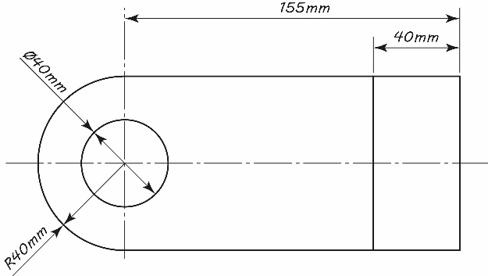
A

(a) The part needs to be drawn to a scale of 1:4.
Calculate the diameter of hole A on the new scale drawing. [1]

(b) The part is currently being designed in the UK using a Computer Aided Design (CAD) software package before being manufactured by an automated machine.
(i) State two advantages of using CAD software to produce the drawing. [2]

(ii) Give one disadvantage of using CAD to produce the design. [1]

(c) Explain two benefits that just-in-time (JIT) manufacturing could have for the manufacturer of the part. [4]

Total 12 Marks

