Homework 3: Modern materials

1. Which one of the following statements is false? [1]
⬨ Nanomaterials are between 1 and 1000 nanometres in size
⬨ Graphene is a carbon lattice structure one atom thick
⬨ Biodegradable polymers are made from petrochemical resources
⬨ Information is transmitted down fibre optic cables using pulses of light

2. Name three different modern materials and describe one use for each. [6]

3. Explain why LCD screens are appropriate for use in a battery powered metronome? [3]
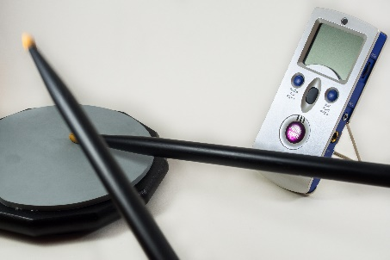

4. Explain why biodegradable polymers are considered to be CO₂ neutral. [3]

5. How might metal foams be beneficial to patients receiving orthopaedic implants? [2]

Total 15 marks

