Homework 6: Systems approach

1. Which one of the following components is used to detect light levels? [1]
⬨ LED
⬨ Thermistor
⬨ LDR
⬨ Resistor

2. Which one of the following is an output component? [1]
⬨ Speaker
⬨ PTM switch
⬨ Pressure pad
⬨ Microphone

3. Explain the functional difference between a closed loop system and an
open loop system. [2]

4. This question is about connecting components together in a circuit.

(a) What is the name for the style of circuit drawn below? [1]

(b) Which electronic component is labelled SW1? [1]

(c) Which electronic component is labelled D1? [1]

(d) Explain the function of resistor R1. [2]

(e) Split the timing circuit below into three blocks by drawing two vertical lines across it.

Label each of the blocks, stating whether it is the input, output or process. [3]
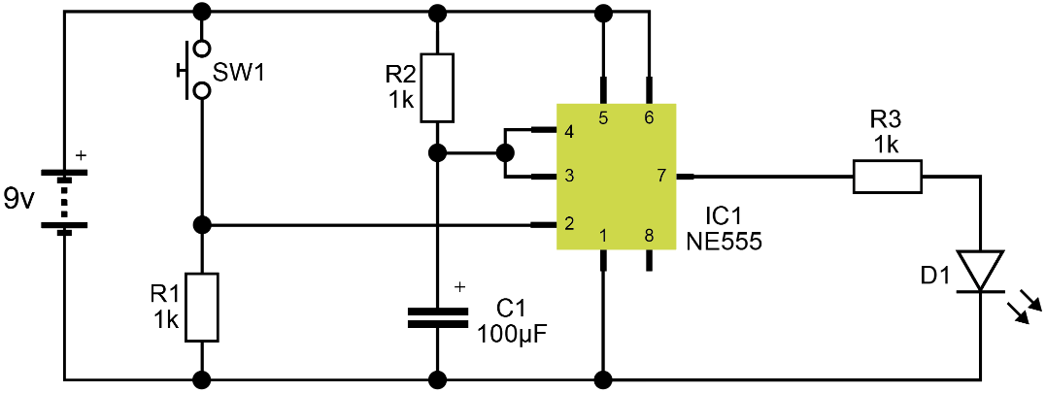

Total 12 marks

