Edition 1 2017/2018
My amazing year
Evan Sephton, Y9, has had what he called “an amazing year”.
“This year I joined the Wigan Athletic Disability Team. I had a brilliant season there. I got player of the season. I got a trophy for winning and it was presented to me by Emmerson Boyce.”
As a reward for representing Hawkley so well outside of school Evan was given a Wigan Athletic shirt. He was also invited down to the training ground to meet the players. “I went to the training ground during a half term and I met all the players. I got all their signatures on my shirt and I got pictures with them all. It was an amazing day to watch them train and see all the behind the scenes at the training ground. I even saw Paul Cook, the manager!”
Evan has made big developments in school this year, and now goes out of Inclusion at break and lunch time. “I started going on the AstroTurf at breaks and lunch this year. I am more confident this year, and now that I’m older I feel like I can talk to the others in my year.”

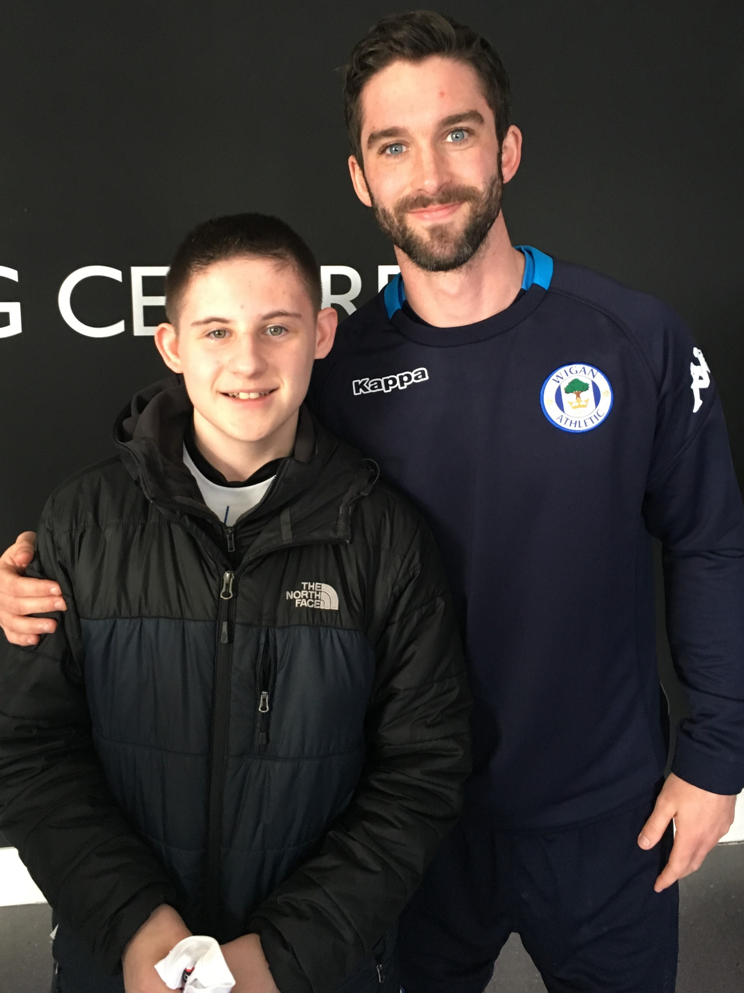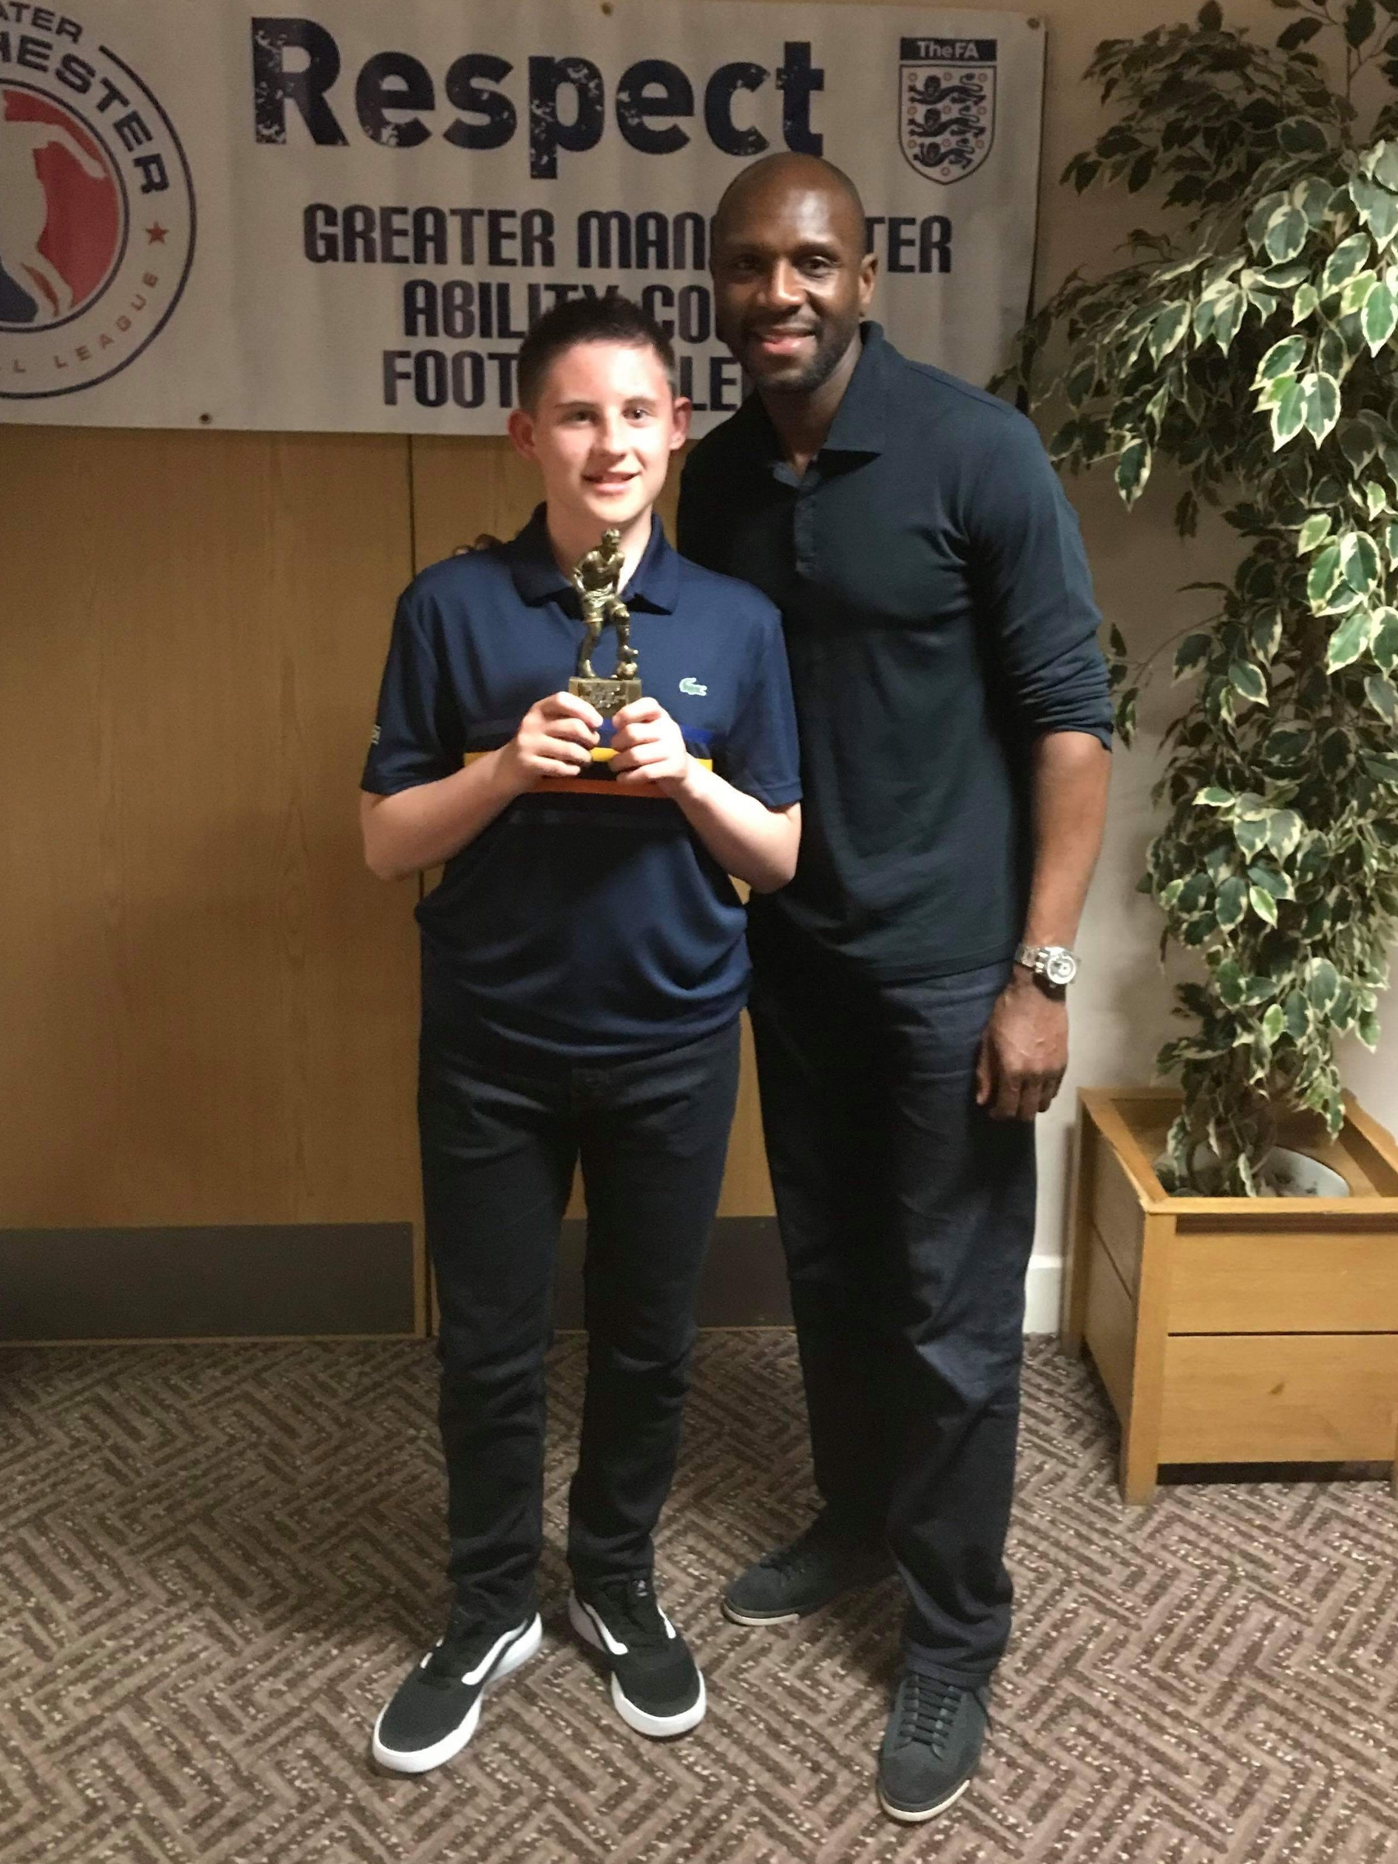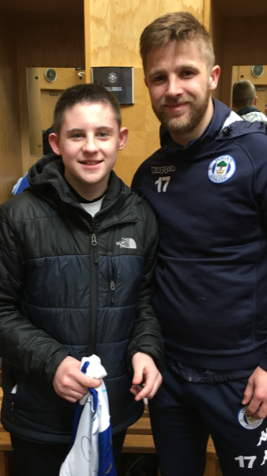

Hawkley Hall High School
SEND Newsletter

My day at the BBC Studios in Manchester
Louis Hilton, Y8, was invited to go on a tour of the BBC studios at Media City, Manchester. When asked about why he was invited on a tour, Louis said “The BBC came in to school to interview us about the Micro: bit. I was really good on camera so they asked us to go for a tour.”
Louis explained his day, and what he thought of it.
“When we got there we went through a small version of airport security. We got patted down by security people. We went up to a big room, sat down, and relaxed. Ed Gamble came in, he’s been on the telly, and he spoke to us about the day. We got to go into the blue room and we went into the BBC Breakfast studio. They showed us the cameras and how it all works. I had a really good day.”

CHARITY WEEKS
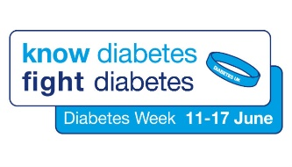
The week is all about creating awareness of the condition and encouraging people to share their experiences of living with diabetes. Diabetes is predicted to become a huge crisis for the future health of the U.K.’s population. It is a health condition that can have a major impact on one’s life and once at an advanced stage, diabetes can cause a host of other health complications.
Diabetes afflicts more people in the U.K. than any other serious health condition. There are 4.6 million Type 1 sufferers and an estimated 12.3 million people are potential type 2 diabetics.

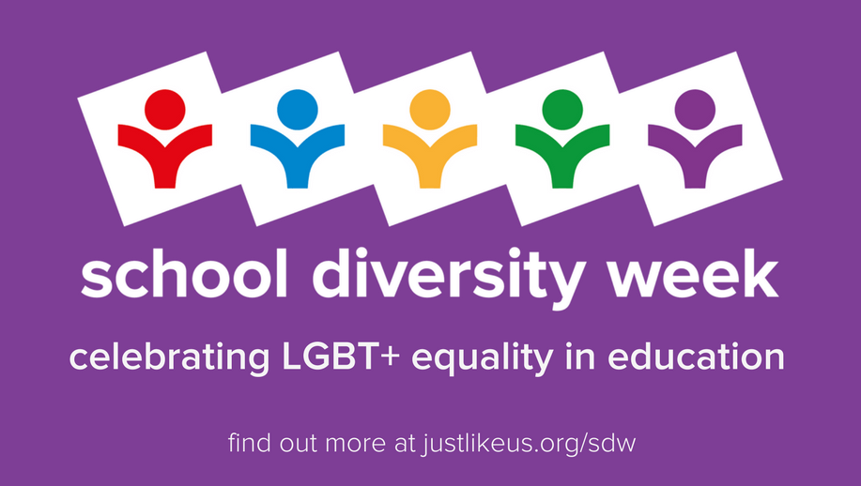

School Diversity Week 2018 (2ND- 8TH July) is the UK’s celebration of LGBT+ equality in education. It’s a great opportunity to inspire student-led social action, developing important life skills like leadership, public speaking and planning.
Its goal is to address the ongoing challenge of growing up LGBT+. Bullying and discrimination remain facts of life for LGBT+ students at school – 96% still hear homophobic remarks – with devastating results: 50% self-harm and 25% attempt suicide.

Michèle Lee awarded MBE in 2018 New Years Honours List
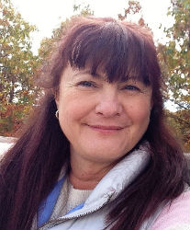

Congratulations to Michèle Lee, Trustee and former Chair of the Dyspraxia Foundation, appointed a Member of the Order of the British Empire.
Eleanor Howes, CEO for Dyspraxia Foundation said “we are delighted that Michèle’s hard work and dedication to dyspraxia has been recognised with this MBE.”
2018 marks the 30th anniversary since we started raising awareness of dyspraxia.
We’ve achieved so much over the last 30 years and our efforts are definitely paying off….
Social Media is a great form of promotion for our 30th Appeal, and we want to build on all that we have achieved so far and over the next 30 years expand our services to further increase understanding of dyspraxia/DCD and reach out to many more people who need us. Using you, we can raise awareness even further. So why not share our 30th appeal with your Facebook followers, Facebook pages that you might manage, your twitter followers, or post pictures on Instagram - or whatever social media channel you prefer! Don't be a stranger and get involved in #Dyspraxia30.

ACHIEVEMENTS

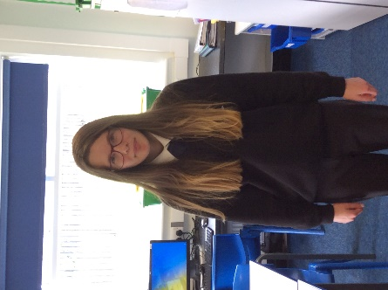
Katie Garry
This year Katie has worked extremely hard being a prefect in Inclusion. She has spent all of her breaks and lunches supervising and supporting year 7 students in G7 and she has done a superb job.

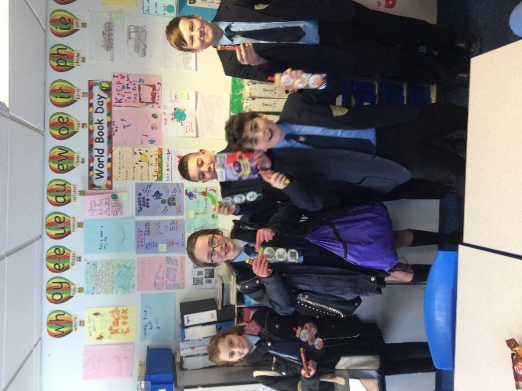

Ellie Taylor, Jessica Thain, Taj Owens, Brandon Gaskell and Joseph Kelly
These students did an excellent job of creating posters for World Book Day to encourage young people to read. It was a very difficult job for Mrs Holmes to judge as all the designs were very creative.

J
Tt

jjjjjj

Quality First Teaching Strategies for students with ADHD

Attention deficit hyperactivity disorder (ADHD) is a behavioural disorder that includes symptoms such as inattentiveness, hyperactivity and impulsiveness. (NHS.UK, 2018) A study carried out by the Centre for Educational Neuroscience Just 1.4% of the 13,586 children asked about had been given a diagnosis at some point (2.2 % of boys and 0.5 % of girls)
Symptoms of ADHD include:
- feeling restless or fidgety
- talking a lot and interrupting
- becoming easily distracted
- finding it hard to concentrate
- saying or doing things without thinking
(Youngminds, 2018)
The following QFT strategies can be used to help and support our students in the classroom
- Instructions broken down into manageable chunks and given in sequence
- Additional time to complete tasks if necessary
- Provide lots of opportunities for kinaesthetic learning e.g. practical activities, experiential learning, multi -sensory resources
- Make expectations for behaviour explicit by giving clear targets, explanations and modelling where possible.
- Communicate in a calm, clear manner Keep instructions, routines and rules short, precise and positive
- Listen to the pupil, giving them an opportunity to explain their behaviours.
(Taken from Quality First Teaching, Wigan Council. 2016)
Useful websites:
https://youngminds.org.uk/find-help/conditions/adhd/?gclid=EAIaIQobChMI9u_ilby32wIVzrDtCh39kggvEAAYASAAEgL9XfD_BwE
http://www.lanc.org.uk/wp-content/uploads/2011/08/what-every-teacher-should-know-about-ADHD.pdf
http://www.sec-ed.co.uk/best-practice/teaching-pupils-with-adhd

Inclusion Celebration Evening 2018
Our Inclusion celebration evening was a success again as we celebrated our students’ achievements and successes throughout 2017-2018. On a very hot evening when England were playing in the World Cup, we were especially thrilled to meet and welcome so many parents, carers, brothers and sisters who came to St. Aidan’s Social Centre to join in the celebrations, take part in a ‘Guess the TA’ baby picture competition and watch some of our students show off their singing talents. It was a pleasure to welcome school governors Andy Wilson (chair of governors), Alison Foster (SEN Governor) and David Stainton, and to see Amy Smith, Gemma Nicholson, Alison O’Brien and Claire Knowles from the teaching staff – thank you for showing your support for the students and their families. Thankyou also to everyone who donated prizes for the raffle, all of which were collected with cheers from the winners and which helped to raise over £90 for Inclusion funds, and to everyone who helped prepare the buffet which was, as always, very popular.
Every student was presented with an award, but special congratulations goes to our KS3 award winners: Gabriella Hough (Endeavour) and Louis Hilton (Achievement), and from KS4 Sean Lynam (Endeavour) and Bradley Woodcock (Achievement). Katie Garry, who has now left us after sitting her exams, also received a special recognition award for her progress and resilience, having successfully overcome many of the challenges she encountered throughout her time with us.
Congratulations and well done also to Helen Croxen, who was presented with flowers for being voted TA’s TA, and to Gary Morton who was voted students’ TA. Both were very well deserved.
