PAPER 2
History GCSE Revision Guide
UNIT 2: Early Elizabethan England
QUESTION TYPES IN PAPER 2:
5a) Describe two features of……[4] –
Simply write TWO facts about the topic/event/person in question and add specific facts and details to show a good knowledge.
POINT: ‘One feature of….. was….
EVIDENCE: ‘For example….
POINT: ‘Another feature of….. was…
EVIDENCE: ‘For example…
5b) Explain why….. [12] –
Explain! ‘This was because…’. Use the reasons provided in the exam paper and then add your own. Aim for THREE REASONS EXPLAINED!
POINT EVIDENCE EXPLAIN X3
- Firstly a reason was…For example…..This explains the reason because….
- A second reason was….For example…..This explains the reason because….
- An additional reason was….For example….This explains the reason because….
5c) How far do you agree? [16]
Use the factors given to you in the question but then think of at LEAST one more of your own. Always make sure you EVALUATE your answer in the conclusion. A BALANCED ANSWER NEEDED with plenty of your own knowledge explained. Make sure you refer back to the question.
- Firstly a reason was…For example…..This explains the reason because….
- A second reason was….For example…..This explains the reason because….
- An additional reason was….For example….This explains the reason because….
- In conclusion the main reason was…..it relates to…..it was the main reason because….(refer back to the question at all times)

IMPORTANT BACKGROUND KNOWLEDGE TO LEARN
What was England like when Elizabeth became Queen?
What was English society like? | - Violent and dangerous  - No police force or army  - No equality  - A clear hierarchy and structure with the rich and poor.
Social Hierarchy Order | - Nobility  - Gentry  - Yeomen  - Tenant farmers  - Landless and working poor  - Homeless and beggars
Town social hierarchy | - Merchants  - Professionals  - Business owners  - Skilled craftsmen  - Unskilled workers
What was the GOVERNMENT like when Elizabeth became Queen?
Court | People close to the Queen who could influence the Queen on important decisions. Made up of the nobility.
Privy Council | Debated issues, oversaw laws, money and parliament. 19 Members and chosen by the Queen. E.g. William Cecil.
Parliament | Passed laws and gave permission for extra taxes. Made up of the House of Commons and the House of Lords. Could only be called upon by the monarch. Elizabeth only called parliament 10 times.
Lord Lieutenant | In charge of training local military forces. One in every county. Were also on the Privy Council.
Justices of the Peace | Large landowners who kept law and order in their local area. Made sure laws were carried out by their people.
The Monarchy
The Divine Rights of Kings. | Believed they had a right to rule the country because of the ‘grace of God’
Elizabeth’s rights as a Queen | She could…….  - Declare war and make peace  - Call and dismiss parliament  - Agree or disagree to laws  - Grant titles, money and land to people.  - Be a patron to a person (give money to support someone)
Secretary of State | The second in charge. Advised the Queen on important matters.
Sir William Cecil | Was Elizabeth’s Secretary of State from 1573 and then became a Lord afterwards.
Extraordinary Taxation | Allowing the Queen and Parliament to raise extra money from taxes in the case of war or needing more money for resources.
Royal Prerogative | Only the Queen had the right to decide on some issues.
Did Elizabeth have the right to succeed?
Legitimate (legal) | Whether a monarch had the right to became a King or Queen. The child has to be born while the King and Queen are married.
Was Elizabeth legitimate? | Elizabeth’s father (Henry VIII) had divorced his first wife Catherine of Aragon in order to marry Elizabeth’s mother Anne Bolyn.
MARRIAGE
Why Elizabeth SHOULD marry | - Having a child will make England more stable – less chance of a take over by another foreign or English ruler.  - A husband could be a military leader in war.  - Would make Elizabeth’s position stronger.  - More accepted by the public.
Why Elizabeth SHOULD NOT marry | - If she married a foreign prince he would think his country was more important.  - Threat of losing power  - The King would be seen as more powerful due to the sexism that existed at the time.
GENDER
Why was her GENDER an issue? | - Christian Religion taught that women should be under the control of a man.  - Women were not thought to be physically, emotionally or mentally able to take control.  - It was usual for women to be in power.  - Public opinion was that a woman should not rule.  - Mary I had given women a bad reputation for her extreme leadership before Elizabeth.
ELIZABETH’S CHARACHTER
Elizabeth’s CHARACTER | - Intelligent and well educated  - Excellent knowledge of politics  - Spoke Italian, Greek, French and Latin.  - She had experienced being a prisoner so could empathise with others in the lower classes.  - She knew the dangers of others challenging her for her power.  - Confident  - Good at speaking to others  NEGATIVE CHARACHTERISTICS  - Had a temper that people feared.  - Decision making took too long.
Problems for Elizabeth 1558-69
What problems did Elizabeth have from home (England) | Money/Finance  - Did not have a lot of money because of costly wars fought when Mary I was Queen.  - England was £300,000 in debt.  - Taxing people was very unpopular but she needed to make up the money.
What problems did Elizabeth face from abroad?  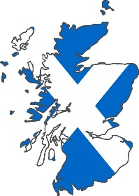 | FRANCE  - France was rich and had a bigger population.  - The French helped the Scottish in border battles between England and Scotland.  - The loss of Calais – The English controlled this port in Northern France and had an army there but lost it after a battle with Spain.  Catholic France and Spain – both were Catholic countries and Elizabeth saw them as a threat to England’s Protestant religion.  SCOTLAND  - Scotland had strong links to France and a history of disagreements with England.  - Mary Queen of Scots - thought she had the right to become the next English Queen after Mary not Elizabeth.  - There was constant fighting on the border between England and Scotland which was difficult to defend.  SCOTLAND AND FRANCE  Had an Auld Alliance (friendship) so would help each other if they went to war with England.  FRANCE AND SPAIN  - Were both Catholic countries and so they were a threat to Protestant England.
The Auld Alliance | The name of the friendship between Scotland and France.
The Settlement of Religion
Features of religion in England | - Dominated by the Catholic church for the previous years but Elizabeth was now more of a Protestant.  - People went to Confession and Mass to forgive sins  - Religious festivals such as Plough Sunday in January and the Harvest Festival  - Religion guided people’s morals and behaviour  - The Reformation began which questioned the Roman Catholic church
Features of the Reformation | - A time when people challenged the Roman Catholic Church and began their own church without the Pope as the head.  - Henry VIII began it in England when he created the Church of England after he wanted a divorce from Catherine of Aragon.
Protestant beliefs | - KING/QUEEN is the leader of the church.  - BIBLE from Latin to English so more people could understand it without having to listen to a Catholic Priest.  - CHURCH DECORATIONS to be removed as the bible did not mention this.  - BISHOPS not mentioned in the bible so should be removed.  - PLAIN and SIMPLE churches that did not show a lot of wealth.  - No POPE  - Sins can only be forgiven by God and not the church.  - MIRACLES do not exist  - PRIESTS allowed to marry.
Catholic Beliefs | 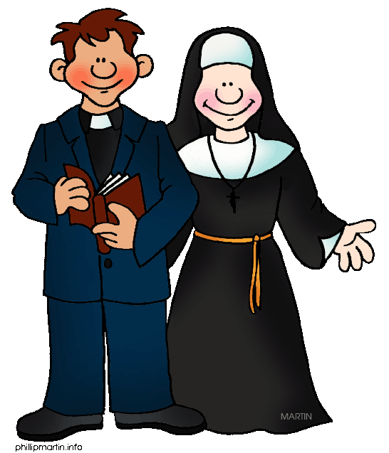  - Pope as leader  - Bishops and priests  - BIBLE read and written in Latin  - The belief in miracles and saints  - Churches hugely decorated to honour the glory of God  - Priests are not allowed to marry.
Who believed in what? | - Henry VIII started Catholic then Protestant after the Break from Rome and divorce from Catherine of Aragon.  - Edward VI was a Protestant  - Mary I was an extreme Catholic  - Elizabeth I was a Protestant but was fairer on Catholics to avoid conflict.
Why was religion a problem for Elizabeth? | - There was lots of tension between Catholics and Protestants all over Europe and England.  - Many Catholic believed Elizabeth did not have the right to become Queen.  - Elizabeth believed other Catholics would try to harm her power at home and from abroad.
Elizabeth’s main RELIGIOUS PROBLEMS | - The tension between Catholics and Protestants  - The geographical division between Catholic and Protestants  London areas more Protestant, rural areas more Catholic.  - The Puritans  Extreme Protestant who had suffered during Mary I’s reign came back to live in England as they felt safer under Elizabeth and tried to influence her.
Religious SETTLEMENT | The way Elizabeth tried to compromise and make all religions happy. She wanted to be fair to all religions.
Features of Elizabeth’s Religious Settlement 1559 | - Act of Supremacy  - Made Elizabeth the supreme governor of the Church of England.  - Clergy had to swear an oath to her.  - Act of Uniformity  - Made sure all church services appeared the same and followed the same rules.  - Everyone had to attend church on a Sunday and Holy Days or be fined what would be a week’s pay.  - Royal Injunctions.  - The same words had to be read out and the same clothes had to be worn by priests.  - A set of instructions on a range of issues to make sure the clergy were following the above acts and people were worshipping in the right way.  - Each Parish had to have a copy of the English Bible  - No one allowed to preach unless they had a licence from the government.  Anyone not following these instructions could be punished.
What was the impact of the religious settlement?  Did everyone follow the new rules?  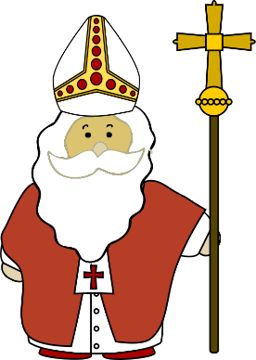 | THE CLERGY  - 8,000 priests took an Oath of Supremacy to the Queen in over 10,000 parishes so this was mainly successful.  - Only ONE BISHOP agreed to take the oath and the others had to step down.  - Elizabeth had to appoint 27 new bishops  - There was a shortage of qualified clergy in Britain  THE PEOPLE  - Most people accepted Elizabeth’s settlement  - Most people attended the new church services.  - Many kept on to old Catholic beliefs too as this was a new change.  - Many people in London destroyed Catholic statues in support of the more basic religious image.  - Most people accepted the wording of the new bible as it was made relevant to Catholics and Protestants.  - More Catholic places such as the north west were slow to change.
THE RELIGIOUS SETTLEMENT  - ACT OF SUPREMACY | - Made Elizabeth supreme governor of the Church of England.  - Clergy had to swear an oath to her.  - A High Commission was set up to keep discipline in the church.  - Clergy members could be punished if they did not follow rules.
- ACT OF UNFORMITY | - Set out the appearance and rules of the church.  - A book of common prayer was to be used in all churches – its wording was to be used.  - The wording was vague/unclear so both Catholics and Protestants could use the prayer book.  - Clergy could be punished if they did not use this.  - Ordered everyone to attend church on a Sunday and other Holy Days.  - People could be fined for not attending (a week’s pay)
- ROYAL INJUNCTIONS | - A set of RULES for the clergy:  - Clergy had to teach its people about the Royal Supremacy.  - Church refusers could be reported.  - Each Parish had to have an English copy of the Bible.  - Not allowed to preach without a licence from the government.  - Clergy had to wear special vestments.  - Allowed some images and decorations in church.  - Any mention of miracles was banned.
Recusant | Someone who refused to follow the new church services.
Features of how the church checked the settlement. | Church Courts  The church made sure people in England followed the new rules of birth, marriage and death. E.g. To check if people wanted to marry, had not already married or were the suitable age to marry or had declared a death via the church.  Enforcing the Settlement  The church was responsible for making sure people were following the rules of the religious settlement.  - Inspections carried out.  - 400 clergy were sacked because of these inspections.  - Other professions such as teachers, midwives and doctors also checked they had a licence.
CHALLENGES TO THE RELIGIOUS SETTLEMENT FROM ENGLAND
The PURITAN challenge  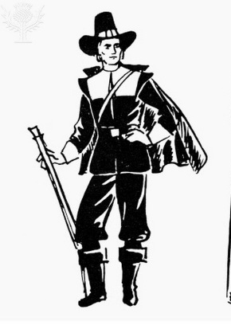 | THE CLERGYMEN  - They wanted a more extreme Protestant Church  - Some Puritan Clergymen began disobeying parts of the religious settlement.  - They did not want music played in church services so refused to play the organ.  THE CRUCIFIX CONTROVERSY  Puritans did not want the symbol of the Crucifix but Elizabeth liked the image and wanted it to continue. Some disobeyed this but Elizabeth did not challenge them.  THE VESTMENT CONTROVERSY  Puritans did not think priests should have special clothing (vestments). Others believed it should be plain and simple.  However, Elizabeth still liked the clergy to wear special vestments.  KEY EXAMPLE: In 1566, the Archbishop of Canterbury held special exhibition in London to show priests what they should wear. 37 refused to attend and lost their jobs.
The CATHOLIC challenge | RULE BY THE POPE (PAPACY)  - Many Catholics still believed the Pope should be the head of the church in England.  THE COUNTER – REFORMATION – A fight back against the changes  - Many Catholics wanted to fight back against the Protestant church had and waged a war against heretics (those that disagreed with the Catholic Church)  THE NORTHERN EARLS/ ENGLAND’S NOBILITY  - 1/3 of the nobility were recusants (did not follow the new church)  - The Gentry/Nobility in the North West of England were recusants (did not follow the new church).  - The Nobility were a more powerful threat to Elizabeth compared to the ordinary people.  KEY EXAMPLE: The Earl of Northumberland led a rebellion in the north against Elizabeth called the Revolt of Northern Earls. They took over Durham Cathedral. They even marched south to gain more support but in 1569 they were forced to turn around as Elizabeth’s troops stepped in.
CHALLENGES TO THE RELIGIOUS SETTLEMENT FROM ABROAD

Challenge from FRANCE | Religious war started in France in 1562 and Elizabeth did not want this war spreading to England. She offered to help the French Protestants but in the end the French Catholic and Protestants made peace with each other anyway,  KEY – She signed the TREATY OF TROYES which gave Calais back to the French.  KEY – She even told Philip of Spain that she supported the Protestants in France and this angered him.
Challenge from SPAIN and the SPANISH NETHERLANDS. | - The Netherlands belonged to the Spanish. King Philip of Spain was a strict Catholic.  - Philip did not like Elizabeth supporting the French Protestants.  - He banned the import of English cloth for a year – this harmed the English economy.  - Trade Embargo between England and the Spanish controlled Netherlands (did not trade with each other).
Challenge from the DUTCH REVOLT (NETHERLANDS) | BACKGROUND:  - The Netherlands belonged to Spain in the 1550s. Philip brought with him the SPANISH INQUISITION (non Catholics would be tortured and killed).  - Protestants in the Netherland united together against Spain because of this. They started a REVOLT/REBELLION against Spain.  FACT: Philip sent 10,000 Spanish soldiers to the Netherlands to defeat the revolt.  FACT: Philip set up ‘The Council of Blood’ to make sure everyone was obeying Catholic laws – thousands of Protestants were killed.  FACT: Some Dutch Rebels travelled to England to try and get support. They were known as SEA BEGGARS
Explain why other countries were a threat/challenge to Elizabeth’s religious settlement. | - The Spanish Catholic Army could have also invaded England over the English Channel.  - The Spanish Inquisition influenced Catholic rebellion in England.  - The Spanish Controlled Netherlands was very close to England.  - Religious war in France could start again and influence a war in England between the Catholics and Protestants.  - Elizabeth wanted to avoid more war – it was expensive.  - Elizabeth was put under pressure from leading Protestants to deal with Spain.  - Elizabeth took gold from an Italian Ship which was meant to be given to the Catholic Spanish – this was known as the GENOESE LOAN. This really angered Philip and this worried Elizabeth about an attack.  - Any action against the Catholics would annoy Philip II of Spain and potentially cause a war with Spain.
THE PROBLEM OF MARY, QUEEN OF SCOTS.
Many Catholics believed that Mary Queen of Scots had a better claim to be Queen. She became Queen of Scotland in 1542 at 6 years old. Her mother was called Mary of Guise and she had a powerful French, Catholic family.
Why did Mary, Queen of Scots not like Elizabeth? | - Elizabeth helped Scotland’s Protestants defeat Mary of Guise while Mary, Queen of Scots was away with her Husband in France.  - Elizabeth secretly sent money to the Scottish Protestants so they could rebel against Mary, Queen of Scots.  - Elizabeth agreed THE TREATY OF EDINBURGH 1560  - Said that Mary, Queen of Scots would not claim to be Queen of England, as long as the Protestants stopped attacking the Catholics.
Why did Mary, Queen of Scots come to England? | BACKGROUND  - Mary was accused of murdering her Husband, Lord Darnley.  - The Protestant Scottish Lords forced Mary to abdicate (give up her throne). She was imprisoned in a castle on a Scottish Island but escaped in 1568 to start a new army.  - She fled to England to get HELP from her Sister Elizabeth.
The plot to make Mary Queen of England | 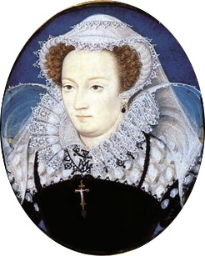  - A Catholic plan was to get Mary, Queen of Scots to marry a very powerful nobleman called Duke of Norfolk who could help her become the next Queen of England.  - Even some of Elizabeth’s favourites gave help to Mary. This proved that Mary was still a threat.  - This was developed into a rebellion by the Catholic Earls Northumberland and Westmoreland.
What did Elizabeth do with Mary? | Kept her in comfort, but under guard as she would still be a threat to Elizabeth.
Reasons why the Religious Settlement was SUCCESSFUL | - Elizabeth’s ‘Middle Way’ was accepted by Catholics and Protestants on the whole.  - There was a growth of the Protestant religion in England.  - Recusants were not treated harshly like under other monarchs  - There were inspections to make sure rules were being followed  - Elizabeth did not kill Mary, Queen of Scots but just kept her ‘out of the way’.  - Catholic Spain and France did NOT invade England  - Elizabeth did not send over English troops to help the Dutch Revolt against the Catholics.
2.1 Challenges to Elizabeth 1569-88
The MAIN threats in this time | 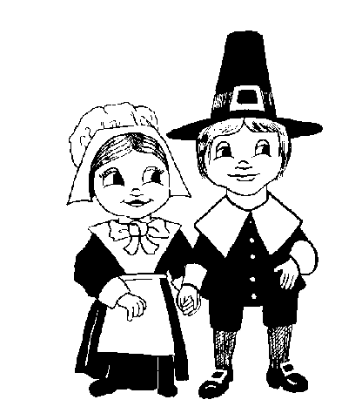  - The Puritans – Vestment Controversy AND Crucifix Controversy  - English Catholics  - Revolt of the Northern Earls 1569  - The Ridolfi Plot 1571  - The Throckmorton Plot 1583  - The Babington Plot 1586  - Mary, Queen of Scots  - Spain  - The Dutch Revolt
Revolt of the Northern Earls
Why did the Northern Earls Revolt in 1569 against Elizabeth?  - RELIGION  - KEY PEOPLE  - POLITICS | - The Earls in the north wanted the Catholic church restored  - The Earls had lost power since Elizabeth became Queen  - Elizabeth did not name an heir to the throne which made them uncertain about the future and think they could get back power.  - They supported Mary, Queen of Scots (Catholic) who could give them leadership and more power.  - Many people in the North remained Catholic and would support the Earls.  - The Earls had a lot of influence under the old Queen, Mary I but lost this under Elizabeth’s power.  - The Earls did not like the new Archbishop of Canterberry James Pilkington.  - The Earls did not like the idea of Mary, Queen of Scots marrying Elizabeth’s favourite at Court Robert Dudley.  - The wives of the Northern Earls also influenced their husbands to revolt.
Who were the main people in the Revolt? | Thomas Percy (Earl of Northumberland) – Catholic. Very important working for Mary I but lost power under Elizabeth. Influenced by his wife to start the revolt as well as from close family members who were also strict Catholics. He was not happy with Elizabeth as he had just lost the rights to a new copper mine to Queen Elizabeth.  Charles Neville (Earl of Westmoreland) – Catholic. From an important family in the North.  Thomas Howard (Duke of Norfolk) – Protestant but had links to an old Catholic Northern family too. Was plotted to Marry Mary, Queen of Scots but he later backed down. He really disliked Elizabeth’s close advisors, especially William Cecil and Elizabeth’s favourite Robert Dudley.  Mary, Queen of Scots – Catholic. Supported the plot to marry the Duke of Norfolk and take over Elizabeth’s throne.  Ann Percy – wife of Thomas Percy and encouraged her husband in the plot.
Who was James Pilkington | Was appointed by Elizabeth as the Archbishop of Durham in 1561 – to hopefully increase the number of Protestants in the north. The Northern Earls did not like him and this was a cause to revolt.
What was the plot? | The Catholics wanted to marry Mary, Queen of Scots (a Catholic) to the Duke of Norfolk (a Protestant) so she would have a strong claim to be the Queen of England.
Features of the Revolt of the Northern Earls | - When Elizabeth knew of the plot, Norfolk was arrested and sent to the Tower of London in 1569.  - The Earls went to Durham and took control of the Durham Cathedral. The Earls destroyed parts of the cathedral.  - They celebrated Mass (Catholic service)  - Mass was celebrated across England over the next two weeks.
Why did the Revolt fail? | - The Spanish did not arrive to support the revolt so not much happened.  - Elizabeth raised an army of 14,000 men against it.  - Elizabeth moved Mary, Queen of Scots to Coventry prison so she could not escape.
The consequences of the revolt. | - 450 rebels were executed throughout England.  - People were scared of Elizabeth’s troops.  - Duke Westmoorland escaped but Northumberland was captured and executed in 1572 (his head was put on a spike above the city gates)  - Elizabeth released the Duke of Norfolk.  - Elizabeth kept Mary, Queen of Scots was kept prisoner for the next 14 years.  - The Pope issued a papal bull (a written order) to all Catholics to get rid of Elizabeth.  - Elizabeth then reacted by being able to arrest anyone who tried to rebel against her.
Why was the Revolt of the Northern Earls SIGNIFICANT? | - It was the first and most serious rebellion against Elizabeth  - It ended the power of important northern families in England.  - It brought about much harsher treatment of Catholics.  - Even the Pope was involved in the issues of England and Elizabeth.
Why was the papal bull significant? | - People in England struggled to decide if they should support their Queen or their religious leader from Rome.
The Ridolfi Plot 1571
Who was Roberto Ridolfi? | - Was an Italian banker living in England.  - He was a spy for the Pope
What did he aim to do? | - He arranged a plot to murder Elizabeth  - The Spanish would then invade England and put Mary, Queen of Scots on the throne.  - For Mary to marry the Duke of Norfolk.
Features of the RIDOLFI PLOT 1571 | - 1571 – Ridolfi left England to discuss his ideas with the Pope and Philip of Spain (who was in the Netherlands)  - Ridolfi had a letter from the Duke of Norfolk saying he would lead the rebellion.  - Philip of Spain told the Duke of Alba to prepare 10,000 men to invade England.  - Sir William Cecil found out about the plot in 1571.  - Duke of Norfolk was arrested and executed in 1572.
What was the SIGNIFICANCE of the Ridolfi Plot? | - It showed that the Catholics were still serious about attacking Elizabeth.  - It showed there was still a huge threat towards Elizabeth.  - It showed the threat of Spain towards England.
The CONSEQUENCES of the Ridolfi Plot | PRIEST HOLES  - After 1574, Catholics were smuggled into England to keep the Catholic faith alive.  - Places they stayed were kept under watch by Elizabeth’s investigators.  - The Catholics hid in ‘priest holes’ which were hiding places where they could not be discovered.  LAWS WERE PASSED  - 1581 – Recusants would be fined £20 (a huge amount of money)  - 1581 – Anyone trying to change a person to a Catholic was know committing treason and could be executed.
The Throckmorton Plot 1583
What was the plot?  Why was it a threat?  - RELIGION  - FRANCE  - SPAIN  - MARY. QOS | For Mary, Queen of Scot’s French cousin called Duke of Guise to invade England.  To free Mary from prison and get Mary in power to make England Catholic again.  Spain and King Philip II would provide money for it to happen and the Pope also knew of and approved the plans.  It was also a threat as it involved Catholics wanting to remove Elizabeth to establish a more Catholic religious rule.
Who was Throckmorton? | Francis Throckmorton – he communicated between Mary and the other plotters. He was a young Englishman who organised the plot.
What happened? | - Sir Francis Walsingham found out the plot.  - Francis Throckmorton was arrested in November 1583  - Executed in May 1584
What was its significance? | - Showed that foreign Catholics were willing to help Mary, Queen of Scots  - Throckmorton had a list of names of Catholic sympathisers in Elizabeth’s court England which Elizabeth could now use. It showed that Elizabeth was not safe, even from her own government.  - Life was made even harder for Catholics as Elizabeth and Francis Walsingham spied on them even more.
The Babington Plot 1586
Who was Anthony Babington? | - A Catholic with links to the French
What was his plan? | - To murder Elizabeth I.  - To encourage English Catholics to rebel.  - The Duke of Guise (French) would invade England with 60,000 men.  - Mary, Queen of Scots would become Queen.  - Both Philip of Spain and the Pope supported the plot.
Features of the Babington Plot 1586 | - Anthony Babington wrote to Mary, Queen of Scots about the plot.  - The plot was discovered as Mary’s mail was always checked.  - It was found by Sir Francis Walsingham.  - All involved were arrested.  - Babington was arrested and hung, drawn and quartered.
The consequences of the plot | - Mary had now been involved in too many plots against Elizabeth.  - The Privy Council tried her and found her guilty of treason.  - Mary was sentenced to death.  - Elizabeth did not sign the death warrant until 1587.  - Mary was executed on February 8th 1587.
Why was this plot SIGNIFICANT? | - By now the relationship between Spain and England had completely broken down, especially as Elizabeth was helping the Dutch Protestants against the Spanish.  - Elizabeth became determined to crush the Catholic faith.  - There were mass arrests of recusants.  - 300 in London alone and 31 priests were executed.  - Mary’s execution brought an end to the idea of her being the next monarch.
Why was Mary, Queen of Scots executed? | - Mary had been involved in too many plots against Elizabeth – this was actually treason.  - If Mary escaped, she would be a threat against Elizabeth again.  - She was found guilty after a trial so there was a legal reason for her to be executed.  - An Act of Parliament was passed called the Act for the Preservation of the Queen’s Safety which meant if Elizabeth was killed, Mary should not become Queen.
What was the SIGNIFICANCE of her execution? | - It removed a threat to Elizabeth BUT  - It gave Philip more of a reason to invade England.
Why was Sir Francis Walsingham important for Elizabeth? | - He was ‘second’ in command as Elizabeth’s Secretary of State.  - He developed a network of spies and informers to uncover plots in England and abroad.  - He paid people for important information so people would even spy on their own neighbours.  - By 1580 – he had spies in 12 towns in France, 9 in Germany and 4 in Spain.  - He used a secret way of writing code (ciphers) so others could not know about his actions against them.  - He persuaded captured Catholics to give him useful information in return for their release.  - He was even prepared to spy on the nobles of England to gain information.
EXAMPLE EXAM QUESTION | Describe two features of the plots against Elizabeth I in the years 1571 – 86 [4]
2.2 ELIZABETH’S RELATIONSHIP WITH SPAIN
- TRADE AND MONEY RIVALRY
Features of Elizabeth’s aims abroad. | - To improve trade – better economy.  - Protect England’s land – stop invasion.  - To protect the English throne  - To avoid an expensive war
BACKGROUND INFORMATION | English merchants explored new trading lands (Russia, China, India, Persia and Turkey).  Huge profits to be made in the ‘New World’ (Americas)
Problems with Spain | - Spain controlled the Netherlands which was England’s main route into Europe  - Spain controlled much of the New World (Florida, Caribbean, Mexico, chili, Peru).
The New World (Americas) | - Could provide tobacco, sugar, silver.  - Anyone wanting to trade in the New World needed a licence from Spain.  - Many English merchants ignored the Spanish rules and even attacked Spanish ports and ships.  - This angered Philip II of Spain.
Privateers | - People who had armed ships who would steel goods from others. They had the support of Elizabeth to do this.
Who was Francis Drake?  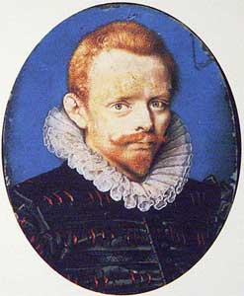 | - He was an English merchant (trader of goods) who made his name and fortune in the New World.  - He also made money from those who invested in his voyages including Elizabeth I.  - He made £40,000 from a trip to Panama from steeling Spanish silver.  - Much of what he did was really piracy. EXAMPLE – He captured many Spanish ships in the West Indies and stole their cargo.  - In 1572, Elizabeth hired him as a PRIVATEER.  - Drake became well known for circumnavigating the globe on his return visit from the New World.
How did Drake cause tension with Spain? | - He took Spanish cargo  - He ignored Spanish trading rules  - Elizabeth supported Drake so this angered Philip II even more.  - Elizabeth gave Drake secret orders to attack Spain’s land in the New World.  - Elizabeth tried to disrupt Spanish trade as this was making them richer.
Consequences of Drakes Voyages | - Drake successfully attacked Spanish ports and ships  - He claimed land in America and called in New Albion.  - When he returned in 1580 – he brought back £400,000 Spanish treasure.  - He used some of this money to fund other voyages.  - He added a lot of money to England’s wealth.  - Elizabeth knighted Drake – this really annoyed Philip II of Spain as it was at the expense of Spain.
The SIGNIFICANCE of Drake | - Drake made it clear that England would not accept Spain’s rule of the New World  - Drake’s circumnavigation of the world made him a national hero and gave England pride in the world.  - He gave England much needed money at the time.  - The knighting of Drake was a huge signal to Spain that Elizabeth supported his attacks.
POLITICAL AND RELIGIOUS RIVALRY.
BACKGROUND | - All countries in Europe were rivals and wanted more territory/land as this would mean more people, wealth and power.  - There was also rivalry between Protestants and Catholics because of this. Countries often made ‘alliances’ which would help them out.  - Spain and England had once been allies but when England became Protestant this ended.
Religious Rivals with Spain | - From 1567 – Spanish ships were sailing to the Netherland to help the Duke of Alba fight against the rising Protestants.  - The Privy Council put pressure on Elizabeth to help the Dutch Protestants.
Why did Elizabeth not send troops to the Netherlands? | - Elizabeth did not want to directly help the Dutch Protestants as this might end up in war with Spain.  - Spain had the backing of the Pope and he might have encouraged a war back against England.  - As France was also Catholic, if Elizabeth had helped, France might decide to help another Catholic country Spain.  - It would be too expensive and Spain was richer.
What did Elizabeth do about the Netherlands? | - She unofficially helped the Dutch fight against the Spanish  - She allowed privateers to attack Spanish ships and land  - She tried to became more friendly with France (which would annoy Spain)  - She encouraged people by word of mouth to fight against the Spanish.  - She sent a loan of £100,000 to the Dutch rebels  - She promised to make sure the Pacification of Ghent 1576 had been carried out.
The Spanish Fury 1576 | - Spain was bankrupt and not able to pay its army. They rebelled in the Dutch city of Antwerp in 1567 and refused to fight. This was known as the Spanish Fury (Fury means angry).
The Pacification of Ghent 1576 | - This was a list of demands put together by the Netherlands during the Spanish Fury. It demanded  - All Spanish troops were to be sent away from the Netherlands  - The Netherlands should be in control of its own government and not Spain  - An end to religious persecution of the protestants (being attacked)  SPAIN AGREED TO THESE IN 1577.
Why did Elizabeth fail at helping the Netherlands? | - Peace only lasted 6 months  - Philip sent another army to attack the Netherlands.  - Elizabeth asked a volunteer to send only 6,000 troops to the Netherlands.  - Elizabeth did not officially declare war on Spain in the Netherlands.  Again, Elizabeth hesitated in her decision making about what to do with the Spanish.  By this point, the Spanish had sent in a far more experienced leader the Duke of Palmer to give the Spanish even more power and the Dutch ended up asking the French for help instead.
The Death of the Frenchman The Duke of Alencon. | - He was helping the Dutch fight the Spanish but died in 1584.  - Elizabeth had to decide if she should now step in and help the Dutch again, but again she could not make her mind up.
The Death of the Protestant Dutch fighter William of Orange | - He was assassinated and again, Elizabeth had to decide if she should step in and help the Dutch against the Spanish.
Why were these deaths significant? | - France and Spain were now very powerful and the Dutch Protestants were weak. A treaty (agreement) was signed between France and Spain which made them allies (friends) with each other. They could now both fight against the protestant religion.
The Treaty of Joinville 1584 | - Joined the French and the Spanish together in an alliance.
Why did Spain have more power in the Netherlands?  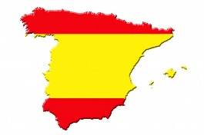 | - Elizabeth was not willing to send troops over officially to fight the Spanish  - Elizabeth was slow and hesitated deciding what to do with the Netherlands.  - Elizabeth did not want to risk war as it would be too expensive  - Key Protestants such as William of Orange and the Duke of Alencon died.  - Elizabeth did not end Spain’s control for good after the Spanish Fury and the Pacification of Ghent 1576. She had a chance and blew it!  - Spain had good military leaders such as the Duke of Palmer who were given the chance to take control.  - Elizabeth allowed France and Spain to sign a treaty which brought together two powerful Catholic countries in Europe.
SUMMARY OF THIS SECTION | - The relationship with Spain got worse over these years  - Elizabeth wanted to avoid war  - Elizabeth took her time and hesitated too much with her decisions  - The Protestant Dutch revolt led to a lot of Spanish military force being sent to the Netherlands. This was seen as a threat to England.  - Elizabeth’s support for the Dutch Protestants was limited  - Sir Francis Drake provoked Philip’s anger with what he did the New World.  - In 1584, circumstances beyond Elizabeth’s meant she had to help in the Netherlands.
2.3 OUTBREAK OF WAR WITH SPAIN 1585-88
The Treaty of Joinville 1584 | - Joined the French and the Spanish together in an alliance.
The Treaty of Nonsuch 1585 | - After Spain and France joined in an alliance, Elizabeth decided to ally with the Dutch Protestants. This effectively put England and Spain at war with each other in the Netherlands.  - Elizabeth decided she would directly help the Protestant Dutch against Spain.
What would Elizabeth do to help the Dutch Protestants? | - Finance an army of 7,400 English troops  - She would decide who the leader of the troops would be.  - She would work with the Dutch Protestant rebels.  - Elizabeth chose Robert Dudley, The Earl of Leicester to take charge  - In October 1585 Elizabeth sent Sir Francis Drake to raid Spanish settlements in the New World to reduce Spain’s finances.
Why was Elizabeth’s help to the Dutch Protestants a failure? | - The attack on the New World angered Philip and Philip told the Pope he would invade England in 1585.  - Robert Dudley, The Earl of Leicester was not given enough money for men or supplies.  - Robert accepted the title of ‘Governor General’ in the Netherlands without Elizabeth’s permission and this angered her AND Philip.  - Robert Dudley, The Earl of Leicester was not able to slow down the Spanish forces in the Netherlands.  - Robert Dudley, The Earl of Leicester and Elizabeth had different aims in the Netherlands. Robert Dudley The Earl of Leicester wanted to free the Netherlands from Spain but Elizabeth just wanted to reduce the Spanish power.  - The Dutch Protestants were not happy with Elizabeth’s lack of support and power.
Why was it a success? | - Robert Dudley, The Earl of Leicester did manage to stop the Spanish Duke of Palma for taking a deep water Port called Ostend which would reduce the number and type of ships the Spanish could send to the Netherlands.
The Consequences of Elizabeth’s involvement in the Netherlands. | - Spanish started to build an invasion fleet in 1586.  - Elizabeth ordered Francis Drake to attack Spain’s Navy in a very important port called Cadiz.  - He destroyed 30 ships.
The ‘singeing of the King of Spain’s beard’ | - The name given to Francis Drake’s attack on Cadiz and destruction of 30 ships.
How did Drake’s attacks affect Spain? | - It disrupted Spain’s building of the Spanish invasion force by a year which brought England more time to prepare for an invasion.
Exam Question | Explain why there was a decline in Anglo-Spanish relations in the years 1585-88 [12]  Politics  - The Spanish and French had already signed an agreement (Treaty of Joinville 1584) which could unite them against England.  - England and the Netherlands signed the Treaty of Nonsuch 1585 in response  Money  - Elizabeth now funded an army against the Spanish in the Netherlands.  Religion  - Elizabeth wanted to officially help the Protestant Dutch  - The Spanish and the Pope both angry with Elizabeth and England  The Role of the Individual  - Robert Dudley annoyed the Spanish by taking the deep water port of Ostend  - Elizabeth now taking more control over how she helps the Dutch fight against the Spanish.  - Sir Francis Drake attacking Spanish ships (the singing of the King of Spain’s beard’) in Cadiz.
- 2.4 THE SPANISH ARMADA
Why did Philip II launch the Armada against the English?  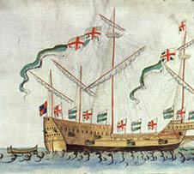 | RELIGION  - Philip II wanted to remove Protestant heretics  - The Pope wanted Elizabeth removed because of her religion.  - The Pope promised to forgive the sins of those taking part in the Armada.  - Spain and the Pope both backed the Catholic plots against Elizabeth  PROVOCATION  - Philip did not like Francis Drakes attacks in the New World  - Philip did not like Elizabeth’s support of the Dutch Protestants  POLITICS  - The Treaty of Joinville 1584  - The Treaty of Nonsuch 1585  - Owning England would make Spain even more powerful and have a bigger Empire.  LUCK/CIRCUMSTANCES  - Spain was also able to own Portugal by 1580 so this gave them confidence to gain more land.  - The Duke of Parma had huge success in the Netherlands against the Dutch and the English.  ELIZABETH I  - Elizabeth hesitated too much to take control of Spain after Spain was weakened in the Netherlands with the Spanish Fury (lack of money) and losing some leaders. This made England seem weak.
What was the Spanish Plan? | - 130 ships  - 2,431 guns  - 30,000 men  - It was the largest fleet Europe had ever seen  - Led by the Duke of Medina Sidonia  - It would meet up with the Duke of Parma and meet up in London to remove Elizabeth.
Why was the Spanish defeated? | 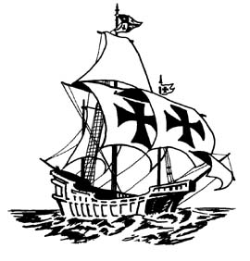  ENGLISH SHIP DESIGN  - English ships were fast and easy to turn – they could use their guns quicker than the Spanish.  - The Spanish galleons were more modern but lacked pace.  - The canons were more effective.  - The canons could be re-loaded by a smaller group of men  - The English canons could be fired more quickly.  THE JOURNEY  - The Spanish were delayed in setting sail because of the weather.  - The Spanish had already been at sea for ten weeks and so were suffering.  SPANISH SUPPLIES  - Spain’s armada was not well supplied.  - Food and drink was stored in poor quality wooden barrels.  - Francis Drake destroyed the fine quality barrels that were to be used.  - Food and drink was already rotting.  - The Armada was low on supplies such as canons and even these were very bad quality compared with the English canons.  PLANNING AND COMMUNICATION  - The plan for the Duke of Medina Sidonia and the Duke of Parma was too complicated to work well enough.  - The Duke of Parma did not have any deep sea ports so the large Spanish ships had to be loaded with much smaller boats which took another 2 days!  - Communication between the two leaders was unreliable. It took a week for some messages to get through.  - Communication was too slow in the English Channel so the two leaders had to attack the English at two different times.  THE BATTLE OF GRAVELINES 8TH AUGUST 1588  - The English sent in fire ships to break up the Spanish fleet. They had the effect of causing chaos and confusing the Spanish ships.  - The Spanish had to fight here without the help of the Duke of Parma who was not ready.  - The weather/wind was too strong for the Spanish.  - Most damage was done which blew the Spanish off course and wrecked the Spanish ships.  - The Spanish ships could not turn around because of the weather and were forced around England.  - Thousands of Spanish were killed.  ENGLISH TACTICS  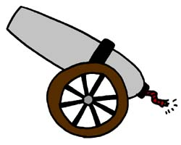  - The English decided to chase the Spanish Armada down the English channel to get them into a place they knew about.  - The Spanish wanted to stop off at the Isle of White to wait for the Duke of Parma but the English stopped them from doing this.  - The English were able to fire 6 times as many cannons than the Spanish.  - The English were able to fire canons from further away to avoid being hit by the Spanish.  PHILIP II  - He ignored the advice given to him by the Spanish sea commanders.  - He selected people to be in charge who were not suitable leaders with poor experience.  - Elizabeth on the other hand had listened to her key military leaders such as Francis Drake.
What were the consequences of the English victory? | - The victory gave Elizabeth a great propaganda victory (made her look really strong to the rest of the world and Spain).  - Elizabeth was part of a great parade in London.  - As the weather helped England, she had the view that clearly God had helped the Protestants.  - A medal at the time said ‘God blew, and they were scattered’.  - As England had survived an attack by Spain it made England look very strong.  - It gave the English pride.  - It showed the strength of the English Navy  - It gave England confidence to explore the world further and trade.  - It did not stop Philip from wanting to give up trying to stop the Protestant faith.
Elizabethan Society 1558-88
  - EDUCATION
THIS DEPENDED ON YOUR SOCIAL CLASS AND GENDER
What were the Elizabethan attitudes to education? | - Attitudes were beginning to change but still showed a divide between rich and poor.  - Education was not about talent and ambition  - Education WAS about helping a person prepare for the life they had been born into.  - Most education would involve practical skills, maybe some literacy.  - Only a small percentage of children, especially boys had any formal education.
New ideas and influences on education | - HUMANISTS believed that learning was very important. This was different to previous views. HUMANISTS wanted people to have a better understanding of the world around them to stop them being superstitious.  - PROTESTANTS believed that people should be taught to read the Bible in English. This would allow people to become more literate.  - BUSINESS AND TRADE meant people were learning more about the world.
Different types of education | 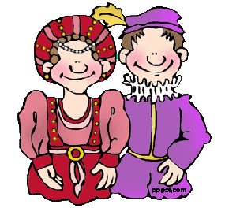  NOBILITY  - Learned foreign languages, Latin and Greek, History, Philosophy, Government.  - Highly educated.  - Noble families ensured girls were also educated.  - Learned skill such as music, dancing, horse riding and archery.  - Taught at home or the homes of other noble families.  UNIVERSITIES  - There were two universities Oxford and Cambridge.  - Would start at the age of 14/15  - Subjects included Music, Astronomy, Medicine and Law.  MIDDLE SORTS AND GRAMMAR SCHOOLS  - Grammar schools started. 42 school created in the 1560s.  - Grammar schools were private schools for boys who came from better off families.  - Girls could not attend grammar schools but were educated at home by their mothers who prepared them for married life.  - Had to pay a fee for a grammar school but some boys could have their fees paid for  - Only had holidays and Christmas and Easter  - Would run from 6am to 4pm  - Studied philosophers such as Aristotle and Plato but would also learn some skills such as archery and chess.  - Great emphasis on memorising huge extracts of writing (like this revision guide)  - Great emphasis on debating issues with other students and teachers.  - School on Saturday morning.  - Two boys were made monitors and had to report poor behaviour.  - Corporal punishment included caning  MAERCHANTS AND CRAFTSMEN  - These children could also have grammar schools  - A lot would be apprentices and would work with their fathers in the future.  - Some boys did not go to school if their family needed them to work in the family business.  - School was not legally compulsory  PETTY SCHOOLS  - Set up in a teacher’s home for boys. Beating for poor behaviour or not doing well was common.  - Bright or well off boys could then be sent to a grammar school afterwards if the parents wanted.  DAME SCHOOLS  - Set up in teacher’s home for girls. Beating for poor behaviour or not doing well was common.  SCHOOLS FOR GIRLS  - Not many girls of all classes would go to school. Mainly went to Dame schools.  - Girls were expected to marry and be under the control of their father and then husband.  - Would learn a variety of skills such as sewing, food, baking, and some first aid.  POOR CHILDREN  - No formal education as they worked.  - They learned what was needed from their family  - Many worked from an early age  - Their jobs did not need numeracy or literacy
What impact did schools have on the Elizabethans? | - 30% of men could read and write at the end of the era.  - 10% of women could read and write at the end of the era.  - Boys’ education certainly improved but not for girls as the time was still very sexist.
LEISURE
THIS DEPENDED ON YOUR SOCIAL CLASS AND GENDER
What were the different leisure activities carried out at this time? | The nobility and gentry would have pastimes including:  - Hunting on horseback  - Hawking  - Fishing  - Fencing  - Real tennis  - Wrestling and swimming (men)  - Gambling (men)  Working people  Football which was very violent and matches could last for hours and included whole villages. No real rules.  Bear Baiting – bear’s teeth broken to be short so they could not bite the dogs. Care taken not to kill the bears as they were expensive.  Cock Fighting – made to wear metal spurs to attack each other. Villages had arenas for this.  Literature – a lot of new writing in this time especially of travel accounts from explorers. Poetry and plays very popular.  Theatre – Mystery plays were common. Elizabeth encouraged (secular) non religious plays as she wanted to remove Catholic ideas. Comedies were also popular.  The first theatre was called the RED LION before the famous GLOBE theatre was built.  - It was popular with ALL classes.  - Only men were allowed to act – women’s parts would be played by men.  - Sometimes queues of 2,000 people  - Pay 1 penny to watch  - The pit was an area right below the stage  - Seats expensive but gave people a higher status.  MUSIC AND DANCING –  - All classes  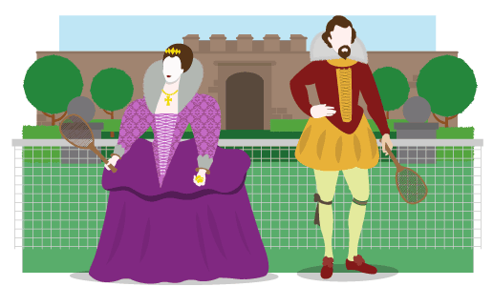  - Many people played instruments such as lutes and harpsichords, fiddles and bagpipes.  - Wealthy families would employ their own musicians during feasts  - Lower class listen to music at fairs or markets  - Music in churches  - Dancing was very popular
THE PROBLEM OF THE POOR
BASIC FACTS ABOUT THE POOR | - The poor were defined as those who spent 80% of their wages or more on ‘bread’.  - 40% of the poor were under 16 years old
Why was their an increase in poverty between 1558-1588? | POPULATION GROWTH  - England’s population grew by 35%, especially in the towns and cities.  - These people in cities needed food  - Food prices were higher in the cities as there was not land to grow it  RISING PRICES  - Poor harvests meant less food and higher prices.  - Grain prices grew which even made bread very expensive.  - Wages did not rise quick enough.  - Landowners charged higher rents.  INCREASE IN SHEEP FARMING  - Price of wool increased  - Sheep farming took over crop farming so there was less food.  - Sheep farming needed fewer workers so some were unemployed.  - The sheep needed feeding too so there was less land to grow human crops.  CHANGES IN ENCLOSURE  - Fields were broken up into smaller and more efficient areas. The landowners and farmers actually became richer but this meant they charged more for their food and land.  - Better ways of farming led to less need for farmers.  - When land was broken up sometimes individual farmers lost land and so would do without.  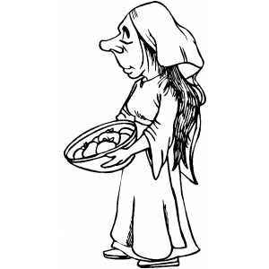  LAND VALUES AND RENTS  - Farm land rent went up so the poor could not afford it.  MOVEMENT OF PEOPLE  - People moved from the countryside to the towns.  - This led to more people being without work and becoming vagabonds  - There was a lack of work in the towns when Spain was at war with England so many became beggars.
BACKGROUND FACTS ABOUT THE POOR | - The poor could get POOR RELIEF  - Many richer people gave to charity to help the poor.  - People were sympathetic towards those who were ill and could not work but believed any were too idle to work.  - People saw more people who were poor in the towns  - Vagrants and Vagabonds (Beggars) were severely punished by whipping and being put in prison.
Why did attitudes and laws towards the poor change? | - People were worried that vagrants and vagabonds would cause more problems.  - The government though unemployment would be bad for the economy
What was done to help the poor? | 1563 STATUTE OF ARTIFICES  - To make sure poor relief was collected  - If it wasn’t paid there would be prison  - Officials were punished if they did not enforce the poor relief payment  1572 VAGABONDS ACT  - Vagrants to be whipped and a whole drilled through their ear  - Vagrants given the death penalty if they were caught begging 3 times.  - There should be a register of the poor  - Towns had to find work for the poor.  1576 POOR RELIEF ACT  - To tell the difference between the able poor and those who were faking their illness.  - Able bodied poor were given wool and raw materials to make things to sell  - Those who refused to work were sent to a special prison known as a House of Correction.
What was the impact of the poor laws? | - Poverty continued  - More people appeared in towns for work  - Less than 10% of vagrants were punished in some towns as people were sympathetic to them.  - Many vagrants were sent back to the countryside from the towns.  - It did prove that unemployment was a problem and people were not just being lazy.  - The Poor Relief Act gave a way for the poor to make something to earn money.
EXPLORATION AND VOYAGES OF DISCOVERY
Why did Elizabethan people want to explore? | EXPANDING TRADE  - Apart from the New World, traders and merchants needed to look for new opportunities as conflict with Spain ruled out some areas.  - Elizabeth funded many voyages of discovery to trade and money.  - Spain had become rich from exploration so England wanted to do the same.  THE TRIANGULAR TRADE  - Africa had already been discovered and it was hoped that it could lead to further opportunities for trade.  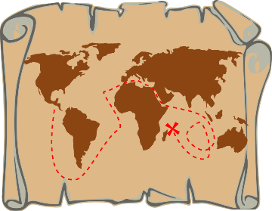  - John Hawkins was a famous navigator and explorer who brought back ginger, sugar and pearls.  ADVENTURE  - Rich, young Elizabethan men went for the sheer adventure.  - They also liked the idea of being heroes and discovering the unknown.  TEW TECHNOLOGY – NAVIGATION  - Navigation was becoming more accurate  - Sailing was therefore becoming safer  - Mathematical ways of navigation were more reliable.  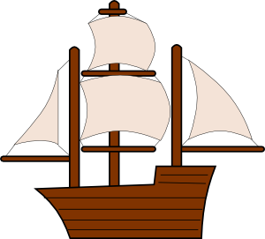  - Quadrants and astrolabes could calculate a ship’s position  MAPS  - Books about these voyages could then be a guide to other explorers.  - Longitude and latitude were created on maps to make sure sailors all followed the same directions.  - Printing maps made them all the same.  SHIPS  - Galleons were much bigger and could carry a bigger cargo for longer journeys.  - Improved sails  - Faster and more manoeuvrable galleons  - Better fire power for galleons
Why Drake circumnavigated the globe and its significance. | SPAIN  He actually set out to attack Spain in the New World but after a defeat they needed a different route back.  MONEY  It would make him rich. In fact he brought back with him over £500 million in today’s money.
Why was Drakes circumnavigation significant? | 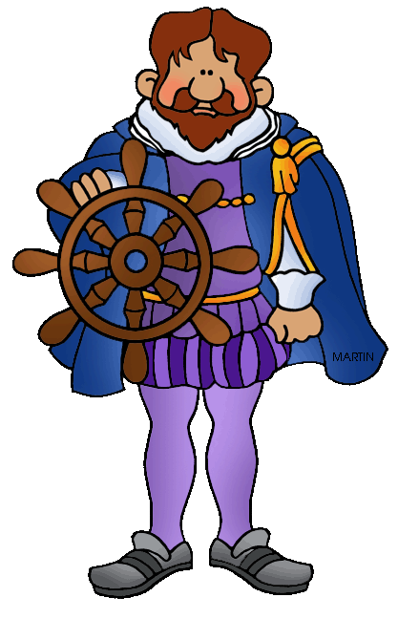  - It showed England as a great sea-faring nation  - It showed great courage – he only returned back with 1 ship ‘The Golden Hind’ and 56 men.  - They were only the second crew in History to achieve this.  - It boosted English morale  - It encouraged more exploration  - Drake made an area in North America called Nova Albion and declared Elizabeth I its sovereign. This peaceful relationship with the Native Americans opened other opportunities  - for further exploration.  - Elizabeth encouraged other colonies in America  - Drake’s actions damaged the relationship between England and Spain
Who was Walter Raleigh? | He was from the gentry  He became an explorer, writer and historian  He made tobacco smoking popular in England  Elizabeth I gave him money to explore land in North America
The significance of Walter Raleigh’s colonisation of Virginia in America. | - He invested, organised and raised funds to make sure the English could set up a colony in Virginia  - He promoted the voyage and persuaded people to leave England and settle in Virginia  - He was even appointed the governor of Virginia  - He persuaded people to take the risk to leave their homes in England and make the dangerous voyage to America.  - He proved to people that a voyage to America was not all about dangerous sea monsters and savages who would kill and eat them in another country.  - He brought two Native Americans called Manteo and Wanchese back to England who taught the English lots about other types of people.  - It gave a chance for Native Americans to barter for goods from England such as woollen cloth.  - New lands would provide work for English cloth makers  - The new lands could send back exotic goods such as gold and tobacco  - It brought plenty of money for England  - The land Walter Raleigh discovered was names after Queen Victoria called Virginia in honour of her being the Virgin Queen.  - Raleigh also invested a lot of his own money into the expeditions.
What were the economic benefits of Raleigh’s voyages? | - Could trade with the Native Americans for exotic goods.  - English cloth makers would gain more work as this was the type of good that the Native Americans liked.  - Could provide exotics goods such as tobacco and gold.  - All of these goods could be taxed and the government could get more money.
Why did Walter Raleigh’s colonisation fail? | - Money – the cost of colonising other lands was huge and just trading was not enough. Elizabeth refused to fund the voyages as she was too worried about what was happening with Spain at the time.  - Finding the sailors – finding suitable and experienced sailors was difficult. Raleigh’s colony only had 107 people rather than the 300 that he needed. (All Men)  - Timing – Raleigh sent 5 ships to Virginia with all the goods needed to harvest crops and grow food. However, by the time they arrived it was too late in the year to grow crops.  - Food and Goods – because of the humid and hot climate, many foods went off and illness were spread too easily.  - Ships damaged – The Tiger was badly damaged and sea water came in destroying the supplies. Crops were destroyed too so could not be planted. They had to rely on the food already in America. They had to forage for seeds and nuts to survive.  - Too high expectations – The colonists believed they would enter a paradise but this was not the reality. They believed they would become rich instantly but this took more time and effort.  - Co-operation – they did not work well with the Native Americans as they expected the Native Americans to do all the work, but this did not work.  - Inexperience – many of the crew were soldiers and would not know how to farm.  - Resistance from the Native Americans – The colonists did have Manteo and Wanchese with them but this was not enough to form good relationships with the Native Americans. One American leader called Virginia turned against the English – there were violent clashes.  - Disease – The English brought with them their own illness that the Native American people could not recover from. This made the Native Americans suspicious of the English and scared of them.  - Roanoke 1587-90 – Many English soldiers found dead and then retaliated by killing the remaining friendly Native Americans.
Who did Raleigh take to colonise America? | - Richard Grenville (Expedition Commander) – experienced, adventurous and feared by his men.  - Ralph Lane (Governor of Virginia) – expert builder, soldier and positive attitude.  - Thomas Harriot (Translator and Mapper) – Had worked with other Native Americans before, good navigator and could translate with the natives.
What was good about Walter Raleigh’s colonisation? | - Elizabeth supported him setting up land in America named after her ‘Virginia’ after the ‘Virgin Queen’.  - She gave him a ship and gunpowder worth £400  - Raleigh was always one of Elizabeth’s favourites.  - Royal support gave the voyage prestige.  - The voyage encouraged others to invest in colonisation.  - Raleigh promised to take any Spanish ships he came across.  - Raleigh invested a lot of his own money on the voyage.
Why was the colonisation SIGNIFICANT? | - UNDERMINED SPAIN – It provided a base to attack Spanish ships safely  - EMPIRE – England had a chance to take more land and compete with Spain in terms of having an empire. The Native Americans could also choose if they preferred the Spanish of the English.  - THE FUTURE EMPIRE - In later years, what was learned here would provide Britain with the experience of having a powerful empire.  - ECONOMY – Trade brought new goods to market in Britain. It meant Britain did not have to depend on Europe where there was pressure from Spain.
PRACTICE EXAM QUESTIONS | ‘Religion was the main cause of the Revolt of the Northern Earls in 1569-70’. How far do you agree? [16]
Explain why the Catholic threat to Elizabeth I increased after 1566. You may use the following in your answer:
- The Dutch Revolt
- Mary, Queen of Scots arrival in England in 1568 [12]
Religion was Elizabeth’s Main problem in the years 1558-69. How far do you agree? Explain your answer.
You may use the following in your answer:
- The settlement of religion
- Mary, Queen of Scots arrival in England in 1568. [16]
 | Describe two features of the attempts to colonise Virginia in the 1580s. [4]
 | Describe two features of the plots against Elizabeth I in the years 1571-86 [4]
Explain why the Throckmorton Plot (1583) was a threat to Queen Elizabeth. [6]
You may use the following in your answer:
- Mary, Queen of Scots
- Foreign threat.
‘The Decline in Anglo-Spanish relations in the years 1569-85 was caused by Elizabeth I’, How far do you agree? You may use the following in your answer:
- Drake’s Voyage to the New World
- The Netherlands
You must also use information of your own. [16]
 | Describe two features of the Elizabethan system of poor relief that were new. [4]
‘The main reason that voyages of exploration were undertaken during Elizabeth’s reign was to increase England’s wealth’. How far do you agree?
You may use the following in your answer:
- Anglo-Spanish relations
- Developing trade
You must use information of your own. [16]
 | Describe two features of the attempts to colonise Virginia in the 1580s [4]
Explain why the attempt to colonise Virginia in 1585-86 was a failure.
You may use the following in your answer:
- The colonists
- Virginia
You must also use information of your own. [12]
 | Explain how Elizabeth dealt with religious problems when she became Queen. [12]
 | Describe two features of the Elizabethan religious settlement. [4]
‘The threat of invasion was Elizabeth’s main problem when she became queen in 1558’. How far do you agree? Explain your answer.
You may use the following in your answer:
France,
Elizabeth’s legitimacy. [16]

 | Describe two features of the Elizabethan religious settlement. [4]
Explain why the Catholic threat to Elizabeth I increased after 1566 [12]

Possible reasons to explain:
- The Dutch Revolt
- The Spanish
- Mary, Queen of Scots
- Religious war in France
- Catholic rebellion in England

Explain why there was a decline in Anglo-Spanish relations in the years 1585-88 [12]
Politics
- The Spanish and French had already signed an agreement (Treaty of Joinville 1584) which could unite them against England.
- England and the Netherlands signed the Treaty of Nonsuch 1585 in response
Money
- Elizabeth now funded an army against the Spanish in the Netherlands.
Religion
- Elizabeth wanted to officially help the Protestant Dutch
- The Spanish and the Pope both angry with Elizabeth and England
The Role of the Individual
- Robert Dudley annoyed the Spanish by taking the deep water port of Ostend
- Elizabeth now taking more control over how she helps the Dutch fight against the Spanish.
- Sir Francis Drake attacking Spanish ships (the singing of the King of Spain’s beard’) in Cadiz.
The Decline in Anglo-Spanish relations in the years 1569-85 was caused by Elizabeth I’, How far do you agree? You may use the following in your answer:
- Drake’s Voyage to the New World
- The Netherlands
- You must also use information of your own. [16]

Other reasons you could use are:
King Philip II’s actions
Religion – Catholics Vs Protestants
The Treaty of Joinville in 1584
‘Religion was Elizabeth’s main Problem in the years 1558-69’. How far do you agree? Explain your answer. (16)

Religious Problems you could include:
- The Threat of religion from England (Catholics and Puritans)
- The threat of religion from abroad (Catholics)
- The impact of the Religious Settlements
- Threat from the Spanish Netherlands/the Dutch Revolt

Other problems:
- Mary, Queen of Scots arrival in England.
- Threat from Spain.
- Her gender
- How legitimate she was
- Whether to marry

