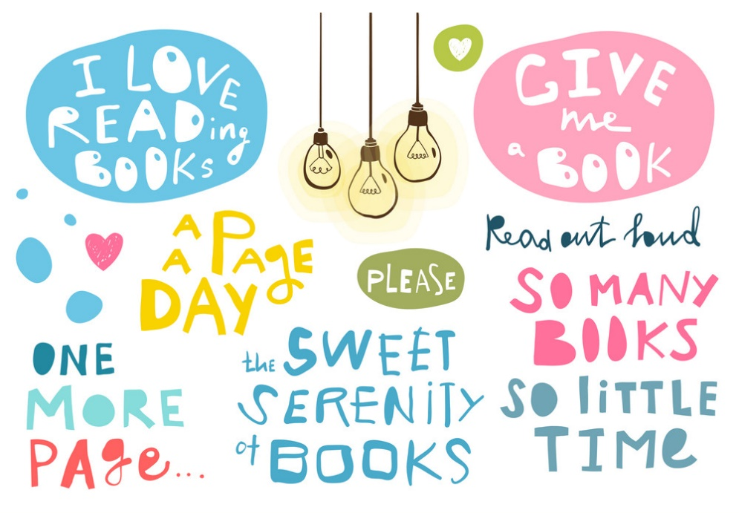
Y6-7 Reading List
- The Amazing Maurice and his Educated Rodents by Terry Pratchett
- You Are Awesome by Matthew Syed
- Ghost Boys by Jewell Parker Rhodes
- A Whisper of Horses by Zillah Bethell
- The 1000 year old Boy by Ross Welford
- Charlie and Me 421 Miles from Home by Mark Lowery
- The Song from Somewhere Else by A.F.Harrold
- The Land of Neverendings by Kate Saunders
- Kick by Mitch Johnson
- Welcome to Nowhere by Elizabeth Laird
- Beetle Boy by M.G.Leonard
Here are is a list of great books that you might like to read over the summer.

