Pre- Transition Guidebook
for
Year 7 parents & students
Compiled May 2020 during the COVID-19 Pandemic to be reviewed July 2020

Dear parents and Y6 students,
This year is very different for me as Head of year 7 as I know it has been for you during your final months of primary school. Due to the Coronavirus, I am making some different arrangements to welcome you to Hawkley. Usually, you would have visited us at school and got to know some of our routines and meet some of our staff, but obviously this year is very different. That being said, I want to reassure you that I am going to do my best to make your transition to Hawkley a good one and hopefully some of the information in this booklet will ease some worries or answer any questions you may have.
Firstly, please do not worry and remember that everyone is in the same position; try to look forward to the times you are going have and the memories you will soon start to make with us. I have spoken to all of your primary school teachers, so I already know lots about you, but I am really looking forward to meeting you and getting to know more about you all and I know that your form tutors and other teachers are too.
Use some of the tips in the pages that follow to start to prepare – familiarise yourself with an example timetable, think about your morning routine and how you will get to school for example.
If you have any immediate questions or worries you can email transition2020@hhhs.net and we will aim to get back to you as soon as possible. Alternatively, use the link on the website to submit your question. Look out also for some ‘Frequently Asked Questions and Answers’ coming soon on the school website, as well as some challenges, tasks and some competitions too.
We are continually waiting on government advice as to what we can do and we want everyone to be safe. I will write to you again very soon with more information on your forms, form tutors and general life at Hawkley so in the meantime, stay safe.

Mrs L. Holland
Head of Year 6/7

How will you know which lessons you are having and where to go?
You will receive an individual timetable when we return to school. It will look something like sample below:
 | Mon | Tues | Wed | Thu | Fri
1 | Miss A O’Brien  Geography  A3 | Mrs N Atherton  Art  A15 | Mrs D J Jackson  English  A9 | Mrs J Mellor  French  G1 | Mrs C Owen  Drama  E2
2 | Mrs J Gooden  Materials Tech  H4 | Mr D Pell  Music  E4 | Mrs C Ali  Physical Ed.  Sports Hall | Mr C Parker  History  A4 | Mrs J Mellor  French  G1
3 | Mrs J Mellor  French  G1 | Miss Sorry  Religious Ed.  A8 | Mrs J Langton  Science  C8 | Mrs M Anderson  Inform. Tech.  A18 | Mrs D Jackson  English  A9
4 | Mrs L. Neil  Food Tech  F10 | Mrs J Langton  Science  C8 | Mr Abrahams  PD  A7 | Mrs N Robinson  Mathematics  F4 | Mrs N Robinson  Mathematics  F4
5 | Mrs C Ali  Physical Ed  Sports Hall | Mrs D. Jackson  English  A9 | Mrs N Robinson Mathematics  F4 | Mrs G Barton  PD  A18 | Mrs J Langton  Science  C8
Letter of the block and number of the classroom.
A Block | English, Art, Geography, History, R.E, Personal Development, Communication | F Block | ICT and Food Technology
C Block | Science | G Block | MFL (French and Spanish) and Inclusion Support
D Block | Maths | H Block | Materials Technology and Textiles
E Block | Drama and music | Sports Hall | Physical Education
I know lots of you might be worrying about getting lost or finding your way around the school, but please don’t! We will do a full tour with you as soon as we can and there is a virtual tour on our website so that you can have a look around and get a feel for the school. Everybody will help Year 7 out in the first few weeks and point you in the right direction too!
There are 5 teaching periods in each day:
Registration | 8.40am to 9.00am
Period 1 | 9.00am to 10.00am
Period 2 | 10.00am to 11.00am
Break | 11.00am to 11.15am
Period 3 | 11.15am to 12.15pm
Lunch | 12.15pm to 12.55pm  (with 5 minutes movement time at the end).
Period 4 | 1.00pm to 2.00pm
Period 5 | 2.00pm to 3.00pm

Will my lessons be in my form group?
There are 8 forms in Year 7 (H, A, W, K, L, E, Y and S) You will have a 20 minute form session every morning where you will spend time preparing for the school day. This may involve form activities, reading, literacy and numeracy work. During form on one of these days we will have a Year 7 assembly as a year group.
From 9am, as you can see from the table above, you will go to your lessons. These will be in different groups and they will vary depending on the subject. They may be in ability groupings, much like your groups for literacy and numeracy at primary school, or they may be mixed differently for other subjects such as practical ones like food technology or design and art. This is because these subjects need smaller classes. This may mean you are with some friends from primary school in some lessons, but not for others. Again, do not worry! By the end of the first morning you will have made new friends with lots of different people – it’s an exciting time with so many new and different opportunities and making new, lifelong friends is just one of them.
More information on your forms will follow in late June.

What useful routines should I try to adapt to in order to make life at High school easier?
Getting to school on time:
- It may be useful to think about how you will get yourself up on time. Many of our students set their own alarm and are responsible for getting themselves out of bed.
- It is important that you know what time to leave the house so that you have enough time to get to school to line up for 8.40am.
- It will be a good idea get in to the routine of checking your timetable the night before so that you can pack your bag in advance. You could make a large copy of your timetable to stick on the fridge/wall. That way you will know what subjects you have each day and when P.E kit/other items need to be brought in.
Homework:
- Most homework will be set on a system called Show My Homework – you and your parents will be given a log in for this so that you can monitor the homework
- A table/desk set aside at home to complete your homework would be a good idea. Parental involvement with homework is the key to ensuring that homework is completed.
- The computers and printers in the Upper Library at school are available every lunch time for Year 7 students and every day after school until 4pm you wish to use them for homework tasks.

Information giving:
- Letters will be sent out from time to time about key events and activities which may have a reply slip attached. Letters will usually be sent home from school on Wednesdays; parents/carer -it may be worth asking your child for letters on this day as sometimes they get buried at the bottom of school bags.

What are the routines for buying food at school?
The dining hall and sandwich room will be open from 8.15am each morning and serves a variety of breakfast items which are available for purchase such as toast, hash browns and bacon sandwiches. This is a good idea for those students who have not had time to get anything before leaving for school.
At break time and lunch time, there are a variety of items available for purchase. This includes bottles of water and various juices.
There are over 1000 students at Hawkley and each one of them requires something to eat at lunch time! We therefore have a first sitting and second sitting in the dining hall (the different year groups take it in turns to be on each sitting).
We have a ‘cashless’ system in school which makes it much quicker for us to serve students at breaks and lunches. Most students use the finger print recognition machines in the canteen/sandwich area and this enables them to ‘top up’ their lunch account when they run low. Again, due to the Coronavirus, we will use another system for the foreseeable future which will most likely be a pin number.
It is a good idea for students to ‘top up’ their accounts before school starts as it is more time consuming to do so at break and lunch. We would also suggest that they ‘top up’ their accounts once a week rather than on a daily basis if this is at all possible.
Students who bring a packed lunch may sit in the sandwich room or eat outside at one of the picnic benches, provided that all litter goes in to the bin.

I’ve heard about The Hawkley Way – what is it?

We are proud of our positive, caring ethos based on a set of expectations we call ‘The Hawkley Way’ which has a fundamental principle at its heart; the principle of mutual respect. The Hawkley Way is a code of conduct which everyone at Hawkley follows. Have a read and ask someone to explain any words you don’t know. Have a look at the questions and think of some possible answers.
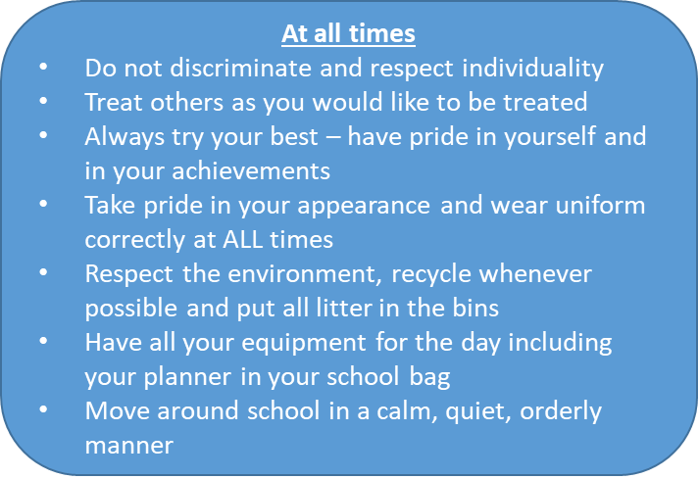
Why is this important?
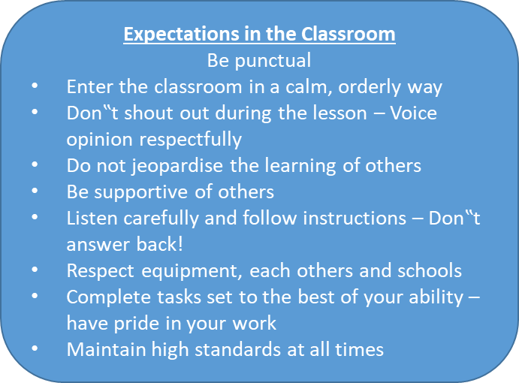
What does this mean to you? How will you do this?
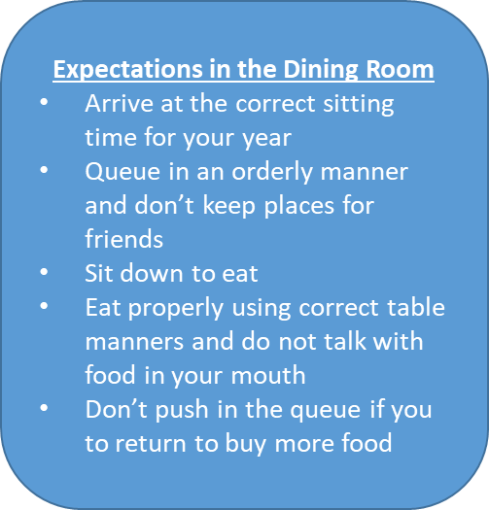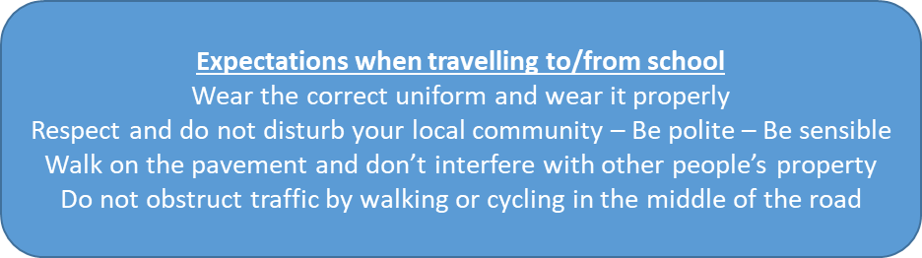
How will you get to Hawkley? Have you planned your route?
You need to allow enough time to get to school for 8.40am every day. To help students keep motivated and organised with this, we have weekly lates detention for anyone who is late to school more than twice in a week.
Are you going to have a packed lunch or buy a hot one? Will you do the same everyday – or perhaps have a Friday ‘treat’ day!
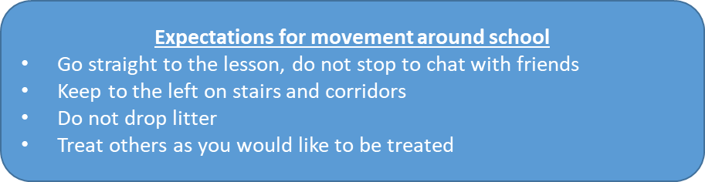
Do you know how many students Hawkley has? If not, see if you can find the answer on our website. With this in mind – why is this point so important?

For parents:
What are the uniform requirements for my child?
At Hawkley, uniform is very important to us and the students wear it with pride. It would really help if names are written clearly or sewn in to each item in case your child mislays any uniform items. Our lost property can sometime become very full and in a school our size it can be tricky reuniting property with its owner!
Please see below for detailed uniform guidelines:
What is not allowed?
- No jewellery except a watch.
- No make up/fake tan/nail polish – students caught wearing these will be asked to remove it.
- No fashion/extreme hairstyles – hair should be of a “natural hair colour” without extreme highlights
- No haircuts shorter than a crop with a No2 setting
- No haircuts with patterns/lines shaved into it (including Mohican/mullet styles).
- No trainers, pumps or leisure type/Velcro fastening shoes.
- No handbags.
- No piercings – covering piercings with plasters is not permitted. Students with piercings will be expected to remove them so we recommend any new piercings are done at the start of the summer holiday so that they are sufficiently healed to allow their removal on return to school.
- No blue or navy coats – they MUST be black
What uniform items are compulsory for Y7 students?
Navy blue blazer with school badge
Pale blue school shirt (without logos or motif)
A full length navy school tie (not a clip on)
Black full shoes (no boots, trainers, Velcro fastening shoes, high heels, open backed flip-flop types or fashion shoes)
Navy, black, dark grey or white socks
Plain black waterproof outdoor coat (no logos or motifs; no denims; no tracksuit tops; no “hoodies”; no fashion coats) Coats should be long enough to cover the blazer.
Boys- black conventional boys tailored school trousers
Girls (compulsory)-Black tailored school trousers with logo or black pleated knee length school skirt with logo which may be worn with black opaque tights.

Optional for All
Navy blue ‘V’ neck jumper with school badge
Navy blue ‘V’ neck slipover with school badge
Navy blue scarves (no pattern or logos)
Approved stockists for Uniform:
Slater's, Eckersley's Mill, Swan Meadow Road, Wigan - Tel 01942 244496
AC Sports, Ormskirk Road, Pemberton, Wigan - Tel 01942 216537
Uniform cards are used each half term. We use this to help us reward the smart appearance of or students. It is signed by staff if uniform is worn incorrectly. If a student has a card with no more than two signatures on it by the end of the term, they are entitled to a non-uniform day. We are delighted that the vast majority of students enjoy this reward on a regular basis.

Slaters
Slaters are currently accepting orders on line at www.acsports.co.uk/shop
They can take orders via email at info@acsports.co.uk
They can arrange call backs from requests to the same email address.

Once they are able to open they will operate within social distancing rules and will offer out of hours appointments. Due to this, please not that they will not be able to deal with as many customers/ orders as usual, so please don’t leave it too late.

