



**Head of Music**

**Recruitment Pack**

Hawkley Hall High School



**Welcome**

Dear Applicant,

Thank you for your interest in the Head of Music position at Hawkley Hall High School.

We are seeking to appoint a dedicated and enthusiastic individual who is ambitious and has an excellent work ethic to join our team from January 2023.

Hawkley Hall is a school with a very positive outlook and a “can-do” approach amongst staff and students. A strong learning culture is evident because there is an acknowledgement that we are all learners, and we can all improve.

To help you decide if the job would suit you, please find enclosed some details, which we hope will give you a flavour of what Hawkley Hall High School and The Rowan Learning Trust are about.

**Please take note of the outstanding facilities we have for the delivery of the music curriculum. I have provided some images below that show our classroom areas, theatre and practice rooms.**

If your values and ambitions mirror ours and you believe you can deliver that vision, then we would be delighted to receive an application from you.

Visits to our school are welcome and can be arranged by contacting Charlotte Walsh on 01942 204640 or email c.walsh1@hhhs.net.

We are committed to safeguarding all members of our community; therefore, all posts are subject to enhanced disclosure procedures and pre-employment checks.

Yours faithfully,

Mr M Klinck

Headteacher

Hawkley Hall High School

**CONTENTS**

Letter from Headteacher

About us

Job Description

Person Specification

How to Apply

Application Form

**Hawkley Hall High School**

**Hawkley Hall is a high performing, heavily oversubscribed, mixed comprehensive school of around 1160 students.**

In April 2018 became the lead school of the Greater Manchester Science Learning Partnership, part of the DfE funded national network, STEM Learning and in February 2019 the school received a very positive Ofsted inspection and was graded as good in all areas.

We see successful education as a partnership between parents, students and ourselves. Links with parents are of paramount importance, with regular and frequent contact via parents’ evenings, reports, newsletters and the school planner contributing to a continuing dialogue about the education we provide for our children.

The school is situated in the south western part of Wigan, close to the M6 motorway, in an area of substantial private development. A wild fowl nature reserve borders the school grounds providing an open attractive outlook to the site.





**The Rowan Learning Trust**

The Rowan Learning Trust (RLT) was established as a Multi-Academy Trust in 2012 to maximise potential of all children, students and adults in our schools and to support them in their journey to become outstanding.

Currently the RLT family comprises six schools: three high schools, an all-through alternative provision academy and two primary schools. Together we share a set of common values:

* Mutual respect
* Fairness
* Equality of opportunity
* Individual growth
* Kindness

We believe in an inclusive workplace – one that is built on fairness, merit and respect to help our employees perform to their greatest potential.

**Job Description**

**Overall purpose of post**

* Work with the Head of Faculty to ensure the provision of an appropriately broad, balanced, relevant and differentiated curriculum for students studying in the faculty, in accordance with the school's aims and curricular policies.
* Support the Head of Faculty when and where appropriate.
* Raise standards of student attainment and achievement within the subject and monitor and support student progress.
* Be accountable for student progress and development within the subject area.
* Be accountable for leading, managing and developing the subject.
* Develop and enhance the teaching practice of others where appropriate.
* Support the aims and objectives of the school.
* Manage effectively and deploy teaching/support staff, financial and physical resources within the department.

**Teaching**

* Undertake an appropriate programme of teaching in accordance with the duties of a standard scale teacher.

**Strategic / Operational Planning**

* Lead the development of appropriate syllabuses, resources, schemes of work, marking policies, assessment and teaching and learning strategies in the Department.
* Be responsible for the day-to-day management, control and operation of course provision with the department, including effective deployment of staff and physical resources.
* Monitor actively and follow up student progress to maximise value added attainment, including students with SEN.
* Work with colleagues to formulate aims, objectives and strategic plans which have coherence and relevance to the needs of the students and to the aims, objectives and strategic plans of the school.
* Lead and manage the planning function of the department, and to ensure that the planning activities of the department reflect the needs of students within the subject area, SIP/DIP and the aims and objectives of the school.
* Comply with the school’s health and safety policy and undertake risk assessments as appropriate
* Link with staff to ensure that the work in the curriculum area fully reflects the school’s distinctive ethos and mission.
* Foster and oversee the application of I.C.T, including the development of materials to support the curriculum and students’ learning.
* Implement school policies and procedures.
* Ensure that health and safety policies and practices, including risk assessments, throughout the department are in-line with national requirements and are updated where necessary, therefore liaising with the school's Health and Safety Manager.

**Curriculum Provision**

* Liaise with the Head of Faculty to ensure the delivery of an appropriate, comprehensive, high quality and cost-effective curriculum programme which complements the Faculty and School Improvement Plans.
* Be accountable for the development and delivery of subject in the curriculum area.

**Curriculum Development**

* Lead the curriculum development in the whole Department.
* Keep up to date with national development in the subject area, pedagogy and methodology.
* Actively monitor and respond to curriculum development and initiatives at national, regional and local levels.
* Liaise with SLT to maintain accreditation with the relevant examination and validating bodies.
* Be responsible for the development of key skills within the curriculum area.
* Ensure that the development of the subject is in line with national developments.

**Staffing**

* Work with the head of faculty and other post holders to ensure that development needs are identified and that appropriate programmes are designed to meet such needs.
* Continue own professional development.
* Be responsible for the efficient and effective deployment of the Department's technicians/support staff.
* Make appropriate arrangements for classes when staff are absent, ensuring appropriate cover within the department.
* Working with other leaders, undertake Performance Management Review(s) and to act as a reviewer for a group of staff within the faculty.
* Participate in the interview process for teaching posts when required and to ensure effective induction of new staff in line with school procedures.
* Promote teamwork and to motivate staff to ensure effective working relations.
* Participate in the school’s ITT and induction programme, as required.
* Be responsible for the day-to-day management of staff within the designated department and act as a positive role model.

Head of Music

Reports to: Head of Expressive Arts Faculty

Location: Hawkley Hall High School, Carr Lane, Wigan, WN3 5NY

Salary: Classroom Teachers’ Pay Scale plus TLR2B

Hours: Full time

**Quality Assurance**

* Ensure the effective operation of quality control systems.
* Establish the process of the setting of targets within the department and to work towards their achievement.
* Establish common standards of practice within the department and develop the effectiveness of teaching and learning styles in all subject areas within the department, in line with school policy.
* Contribute to the school procedures for lesson observation and feedback.
* Implement school quality procedures and to ensure adherence to those within the department.
* Monitor and evaluate the curriculum area in line with agreed school procedures including evaluation against quality standards and performance criteria.
* Seek/implement modification and improvement where required.
* Ensure that the department's quality procedures meet the requirements of self-evaluation and the Strategic Plan.

**Management Information**

* Ensure the maintenance of accurate and up-to-date information concerning the Department on the management information system.
* Make use of analysis and evaluate performance data provided.
* Identify and take appropriate action on issues arising from data, systems and reports; setting deadlines where necessary and reviewing progress on the action taken.
* Produce reports within the quality assurance cycle for the department.
* Produce reports on examination performance, including the use of value-added data.
* In conjunction with the relevant member of the SLT, manage the department's collection of data.
* Provide relevant information relating to the departmental performance and development for a range of audiences, including the Governing Body.

**Communication and Liaison**

* Ensure effective communication/consultation as appropriate with the parents of students.
* Ensure that all members of the department are familiar with its aims and objectives.
* Liaise with partner schools, higher education, industry, examination boards, awarding bodies and other relevant external bodies, as appropriate.
* Conduct regular student and parental voice activities within the Department.
* Lead the development of effective subject links with partner schools and the community, promoting subjects effectively at liaison events in school, partner schools and the wider community.
* Represent the department's views and interests.
* Contribute to the planning and delivery of school liaison activities.
* Promote actively the development of effective subject links with external agencies.

**Management of Resources**

* Support the HOF in reviewing available resources of space, staff, money and equipment efficiently within the limits, guidelines and procedures laid down; including deploying the department budget, acting as a cost centre holder, requisitioning, organising and maintaining equipment and stock, and keeping appropriate records, relevant to the KS.
* Work with the head of faculty/designated member of SLT in order to ensure that the teaching commitments are effectively and efficiently time-tabled and roomed.

**Pastoral System**

* Act as a form tutor and to carry out the duties associated with that role as outlined in the generic job description/staff handbook**.**
* Monitor and support the overall progress and development of students within the department.
* Monitor student attendance together with students' progress and performance in relation to targets set for each individual, ensuring that follow-up procedures are adhered to and that appropriate action is taken where necessary.
* Contribute to the PSHE programme according to school policy.
* Ensure the behaviour management policy is implemented in the department so that effective learning can take place.

**School Ethos**

* Play a full part in life of the school community, to support its distinctive mission and ethos and to encourage and ensure staff and students to follow this example.
* Support the school in meeting its legal requirements for worship.
* Contribute to the delivery of the PSHE programme
* Promote actively the school’s corporate policies.
* Comply with the school’s health and safety policy and undertake risk assessments as appropriate

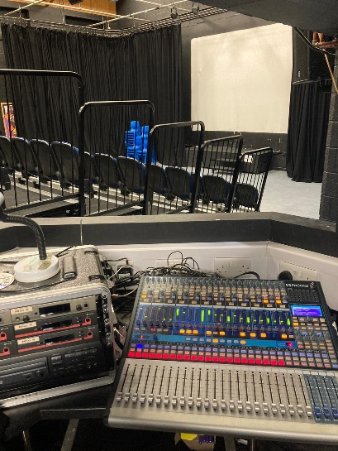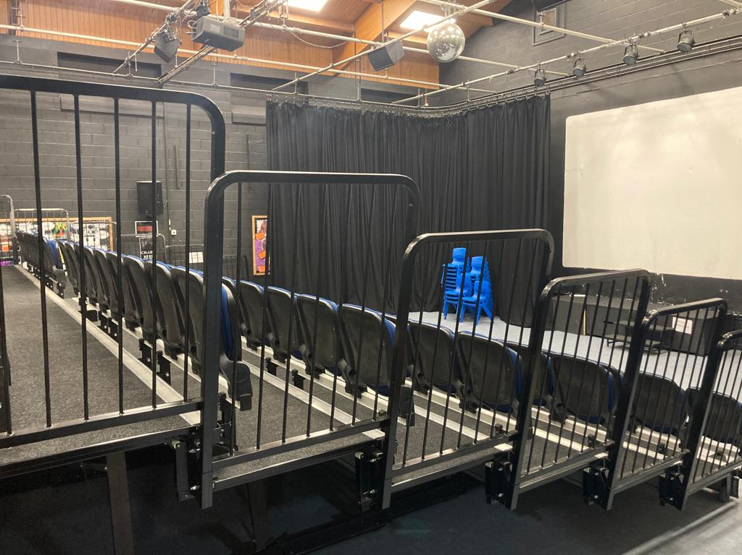

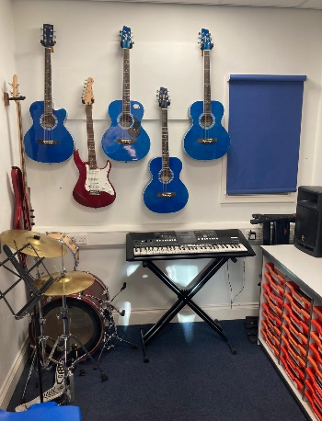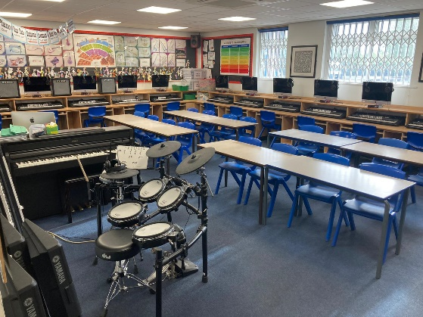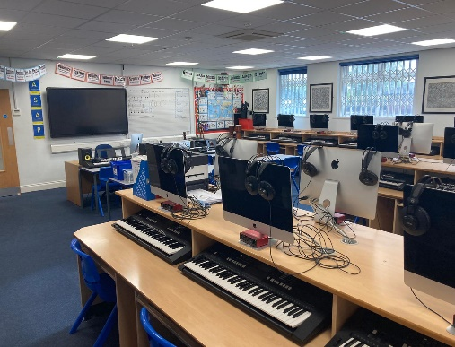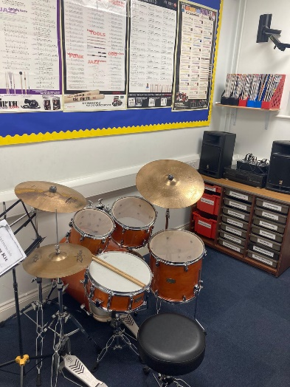

Other available resources include:

* A full compliment of acoustic guitars (right and left-handed)
* A selection of Yamaha Electric Guitars and Bass Guitars
* A variety of Roland and Ampeg guitar amplifiers.
* Roland TD15 Electric Drum Kit
* Yamaha Acoustic Drum Kit
* A selection of Brass instruments
* dB Technologies PA system with Mackie mixer
* 2 Focusrite 18i20 audio interfaces
* KRK Monitors for audio playback
* Various other music technology and performance resources

The Drama Studio features a full range dB Technologies PA system with a Presonus Studiolive 24 digital mixing desk and a range of moving head and static lighting. 6 Sennheiser radio mic transmitters and receivers, and a variety of Shure and AKG microphones are also available for musical production / concerts.

2 large classrooms and 4 smaller practice rooms.

Each classroom is equipped with:

* Teacher Mac desktop connected to 'C-Touch' interactive board.
* A full suite of Mac Desktop computers running Logic Pro X DAW and a range of Microsoft applications.
* A full suite of Yamaha PSR 423 MIDI keyboards and additional Yamaha NP12 'Piaggero' piano keyboards
* A full suite of Focusrite 'Scarlett' audio interfaces.
* A Yamaha MG12 XU mixer connected to stereo audio playback.
* A full compliment of hand-held percussion instruments
* A Roland HP704 Electric Piano
* A full compliment of ukuleles

**Music Department Facilities**

**How to Apply**

**Person Specification **

**Essential**

* Excellent classroom teaching skills that stretch students of all abilities
* The ability to develop effective working relationships with students
* A high degree of management and organisation
* A commitment to continuing professional development
* The ability to command the respect of staff and students.
* A thorough knowledge of the Music curriculum
* Obvious enthusiasm for the subject and the ability to pass this on to students.
* A high degree of student achievement at Key Stage 3 and 4.
* A willingness to share best practice and learn from others.
* The ability to work as a supportive team member.
* Use of ICT skills to aid the delivery of the curriculum.

Please submit the enclosed application form and a supporting statement of no more than two sides of A4 outlining why you are interested in the opportunity and how your application addresses the requirements for the role.

Applications should be returned electronically to [jobs@hhhs.net](mailto:jobs@hhhs.net)

Alternatively, send a hard copy to:

Mr M Klinck

Headteacher

Hawkley Hall High School

Carr Lane

Wigan

WN3 5NY

Closing Date: Saturday 8th October 2022 at 23:59pm





The Trust will make any necessary reasonable adjustments to the job and the working environment to enable access to employment opportunities for disabled job applicants or continued employment for any employee who develops a disabling condition.

All appointments are subject to satisfactory references, proof of qualifications and eligibility to work in the UK.

The Trust is committed to safeguarding and promoting the welfare of all children and young people and expects all staff to share this commitment. An enhanced DBS check will be required.

The Trust will make any necessary reasonable adjustments to the job and the working environment to enable access to employment opportunities for disabled job applicants or continued employment for any employee who develops a disabling condition.

All appointments are subject to satisfactory references and eligibility to work in the UK.

The Trust is committed to safeguarding and promoting the welfare of all children and young people and expects all staff to share this commitment. An enhanced DBS check will be required.



The Rowan Learning Trust

Registered Office: Carr Lane, Wigan, WN3 5NY

Company Number 8010464

**HAWKLEY HALL HIGH SCHOOL**

**JOB APPLICATION FORM FOR TEACHING STAFF IN SCHOOLS**

*The School and Governing Body are committed to equal opportunities in employment and welcome applications from all sections of the community.*

*CARR LANE,*

*WIGAN, WN3 5NY*

***TELEPHONE:*** *01942 204640*

***FACSIMILE:*** *01942 403570*

***EMAIL:*** *jobs@hhhs.net*

1. **POST APPLIED FOR**

|  |  |  |  |
| --- | --- | --- | --- |
| **Post Applied For:** |  | | |
| **School:** | Hawkley Hall High School |  |  |
| **As advertised in:** |  | **On date:** |  |

**2. PERSONAL DETAILS**

|  |  |  |  |  |
| --- | --- | --- | --- | --- |
| **SURNAME:** |  | **FORENAME:** | |  |
| **TITLE:**  **(Optional)** |  | **Date of Birth:**  **(Optional)** | |  |
| **Address:** |  | | | |
|  |  | | | |
| **POSTCODE:** |  | **Email:** |  | |
| **Telephone No:** |  | **Mobile No:** | |  |
| **Email:** |  | **DfE No:** | |  |

**3. CURRENT POST**

|  |  |  |  |  |
| --- | --- | --- | --- | --- |
| **SCHOOL/SERVICE:** |  | | | |
| **LOCAL EDUCATION AUTHORITY:** |  | | | |
| **JOB TITLE:** |  | | | |
| **DATE OF APPOINTMENT:** |  | | **SALARY:** |  |
| **TLR/ Recruitment and Retention Allowance (please specify as applicable)** |  | | | |
| **MAIN DUTIES AND RESPONSIBILITIES** | | | | |
|  | | | | |
| **Reason for this application** | |  | | |

**4. PREVIOUS TEACHING EXPERIENCE**

|  |  |  |  |  |
| --- | --- | --- | --- | --- |
| **Name of school, type of school and number on roll** | **Dates of employment** | | **Post(s) held indicating salary points / allowances** | **Reasons for leaving** |
|  | **From** | **To** |  |  |
|  |  |  |  |  |

**5. OTHER RELEVANT WORK EXPERIENCE**

|  |  |  |  |  |  |
| --- | --- | --- | --- | --- | --- |
| **Post** | **Dates** | | **Employer** | **Grade/Salary** | **Reason for Leaving** |
|  | **From** | **To** |  |  |  |
|  |  |  |  |  |  |

**6. GENERAL EDUCATION**

|  |  |  |  |
| --- | --- | --- | --- |
| **School** | **From** | **To** | **Qualifications – Grades, awarding bodies and dates** |
|  |  |  |  |

**7. FURTHER AND HIGHER EDUCATION**

|  |  |  |  |
| --- | --- | --- | --- |
| **Name of College/ University** | **From** | **To** | **Qualifications – Grades, awarding bodies & dates** |
|  |  |  |  |

**8. ANY OTHER RELEVANT QUALIFICATIONS**

**Please give details of any other relevant qualifications you have for this post.**

|  |
| --- |
|  |

**9. ADDITIONAL INFORMATION**

|  |  |
| --- | --- |
| Are you related to, or a close friend of, any member of the Trust or of the Governing Body of the school? *(If yes, please state relationship)* | Yes / No |
| Have you left any previous job for the reason of redundancy or are you in receipt of an occupational pension?  *(If yes, please give details)* | Yes / No |
| Have you ever been dismissed from any previous employment on the grounds of misconduct or incapability?  *(If yes, please give details)* | Yes / No |
| Do you hold a current and valid driving licence?  *(if yes, please state the category)* | Yes / No |
| Please indicate if you have any special requirements to allow you to participate fully in an interview. |  |

**10. Criminal convictions or cautions**

|  |  |
| --- | --- |
| You should note that the disclosure of any offence will not necessarily prevent the Rowan Learning Trust from employing you, but we reserve the right to consider its significance in relation to working with children.  Work at the school is exempt under the Rehabilitation of Offender Act 1974. Any offer of appointment will be dependent upon the successful completion of the Disclosure and Barring Service (DBS) check at the Enhanced level.  Where serious concerns as to an individual’s suitability to work with children are expressed, the facts will be reported to the relevant authorities. | |
| Do you have any unspent criminal convictions, cautions or bind-overs?  If yes, please forward details (date, offence and sentence) with a covering letter, in a sealed envelope marked “Addressee Only – Headteacher”. | Yes / No |

**11. REFERENCES**

Please state the names and addresses and telephone numbers of two persons from whom references may be obtained. **One must be your current or most recent employer**. In the absence of previous employment experience, a reference from your last place of full-time education will be a suitable alternative.

|  |  |  |  |  |  |  |  |  |  |
| --- | --- | --- | --- | --- | --- | --- | --- | --- | --- |
| **REFEREE 1** | | | | | **REFEREE 2** | | | | |
|  | | | | |  | | | | |
| **TELEPHONE NO:** | |  | | | **TELEPHONE NO:** | |  | | |
| **EMAIL:** | |  | | | **EMAIL:** | |  | | |
| **Reference Type:**  (Please circle) | Employer | | Education | Character | **Reference Type:**  (Please circle) | Employer | | Education | Character |
| Please note that we will contact these referees if you are short-listed for this post and seek reference before interview. | | | | | | | | | |

**12. FURTHER INFORMATION FOR CANDIDATES**

* You will receive no further communication unless selected for interview. If you have therefore not been contacted within three weeks of the closing date for applications, you should conclude that, unfortunately, you have been unsuccessful on this occasion.

* Under the Data Protection Act, the Trust and the Governing Body will use the information given for the purpose of recruitment and selection. Strict confidentiality will be observed and if you become an employee, the information will be used for personnel, pay and pensions administrative purposes only.

* To comply with the Asylum and Immigration Act 1996 (as amended by S.147 of the Nationality, Immigration and Asylum Act 2002), all prospective employees will be required to supply evidence of eligibility to work in the UK. If you are appointed to the post you will be provided with further information detailing what documents will be required.

**THANK YOU FOR YOUR INTEREST SHOWN IN THIS APPOINTMENT**

**13. DECLARATION**

To the best of my knowledge and belief all the particulars I have given are true. I understand that any false statements may disqualify me from employment or render me liable for dismissal. I also understand that no offer of employment made to me will be binding unless confirmed in writing.

I also understand that this post is subject to a satisfactory enhanced Disclosure and Barring Service (DBS) check and to satisfactory medical clearance and the provision of documentary evidence (e.g. NI Number) that shows I am entitled to work in the U.K.

Signature:……………………………………………………………………………Date:…………………………………………………………