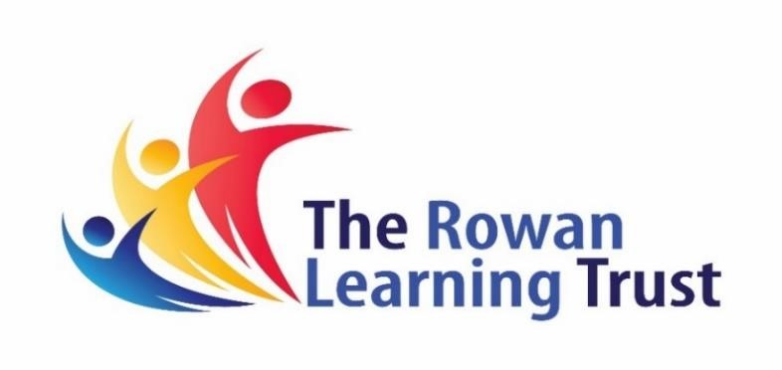

ANTI- BULLYING POLICY

ADOPTED AT THE MEETING OF THE
LOCAL GOVERNING BODY
HELD ON: 7th July 2022

CHAIR OF GOVERNORS: L. Fazackerley

HEADTEACHER: M.Klinck

HHUAB
‘Hawkley Hall- United Against Bullying’
The aim of this policy is to guide students, staff, parents and carers so that we can ensure that Hawkley is a safe school community which is free from bullying. We want all stake holders to know what to do if they believe a student that they know is being bullied by another student (or students) at Hawkley.
The values and ethos of Hawkley Hall High school are underpinned by mutual respect. Therefore, if bullying of any student was to take place by other students from our school community we would consider this to be seriously undermining The Hawkley Way. Every child at Hawkley has the right to feel safe, happy and accepted at school.
In Preventing and Tackling Bullying (2017), The Department for Education states that:

‘Bullying is behaviour by an individual or group, repeated over time, that intentionally hurts another individual or group either physically or emotionally’.

Bullying may occur because:
- A person or group of people are of a particular race, religion or have a particular culture
- A person or group of people has a special educational need, disability or health or mental health condition
- A person or group has a certain appearance
- A person or group has a particular sexual orientation or identity
- A person or group of people has a particular set of home circumstances (for example if they are Looked After or are from a more or less affluent background)
- OR simply because a person or group of people have taken a dislike to somebody for no particular reason at all and/or may be holding a grudge
Whatever the reason for bullying, it will not be tolerated at Hawkley.
The act of bullying may include:
- Repeated physical aggression
- Repeated ridiculing or verbally abusing a person or group
- Repeatedly intentionally humiliating a person or group
- Repeated sexist behaviour
- Cyber-bullying
- Repeatedly intentionally (but quietly) wearing somebody down on purpose. This could be done in a very subtle way so that others do not notice that it is happening. This type of bullying is often very hard to detect and therefore it is important that all members of the school community remain vigilant. In addition, some students may be unaware that they are being bullied but just because they do not realise, it does not mean that it should continue.
Some children may be extremely good at covering up that they are being bullied, but there are often some more noticeable signs such as:
- Changes in eating habits
- Disrupted sleeping pattern
- Performance at school dwindles
- Decreased self esteem
- Sudden loss of friends or changes in friendship group
- Being withdrawn or argumentative
- Unexplained injuries
- Someone saying that they feel ‘ill’ more often than usual – more headaches and stomach aches
- Self destructive behaviours such as self-harm, talking about suicide or running away from home

I am being bullied or someone I know is being bullied- what should I do?

Everybody is different. Some people find that they can talk easily about how they feel inside and some people find it very difficult. For this reason, there are different ways that Hawkley students can report that they, or a friend are being bullied.

‘Hawkley Hall United Against Bullying’

Advice for students
What to do if you suspect that bullying is occurring or if you are being bullied:
- If in doubt, report it straight away. It is better to err on the side of caution.
- Don’t suffer in silence if you feel that you are being bullied - please report the issue to an adult or friend. If staff are unaware of an issue, they will find it difficult to help.
- You may feel more comfortable speaking to another student such as one of the Peer Supporters.
- Tell someone, even if you don't think it will help. Just talking about a situation can help put it in perspective.
- Keep a record of incidents
- Call the Childline (0800 1111).
- If the bullying is taking place online via a website, click the ‘report abuse’ option
If a friend is being bullied:
If a friend, or someone you know is being bullied you can do something about it. Even if you don’t feel as though you can step in and stop the situation yourself, there are still things you can do, like:
- Don't stay and watch or encourage bullying. Walk away.
- Don't get involved in harassment, teasing or spreading gossip about others off or online.
- Don't forward or respond to offensive or upsetting messages or photos.
- Support the person who is being bullied to ask for help. For example, you could go with them to a place they can get help or provide them with information about where to go for help.
- Tell a trusted adult who might be able to help.
- Be friend and listen to the victim.

What will happen once bullying has been reported?
Allegations of bullying will be dealt with sensitively in the first instance so as to not inflame the situation. It is important however to bear in mind that bullying is difficult to tackle without approaching the alleged perpetrator and bullying is difficult to tackle if incidents are not reported straight away

The procedure that should be taken by staff in school is as follows:

Once the incident has been dealt with the following may or may not be appropriate:
- A letter of apology and/or mediation can occur. Mediation should also occur if all parties feel comfortable in taking part in this
- A restorative solution
- The person who has been bullied will be given the opportunity to have a named trusted adult or Peer Support mentor who they feel confident to talk to going forwards
- Work on confidence building and self-esteem could be offered
- The perpetrator of the bullying may also require support. This could take place in the form of mentoring or counselling
In extreme cases of bullying, it may be necessary for school to refer an incident to the police. Parents/carers are also well within their rights to report to the police.

When is bullying not bullying?
When a person perceives that they are being bullied, we must take their perception seriously. Even if a person on the outside looking in to a situation feels that bullying is not taking place, we must still take seriously how a particular person is feeling and consider why they may be feeling this way. In particular, for example, if a child has a special educational need, their perception of their surroundings and what is happening may be very different to that of somebody else. An investigation must still take place to rule bullying out.
There can be a fine line between ‘friendship issues’/‘falling out’ and ‘bullying.’ We should ask ourselves:
Is it repeated behaviour over time? And is it intentional?

Bullying outside the school premises
Headteachers have a statutory power to discipline students for poor behaviour outside of the school premises. Section 89 (5) of the Education and Inspections Act 2006 gives Headteachers the power to regulate students’ conduct when they are not on the school premises and are not under the lawful control or charge of a member of school staff. This can relate to any bullying occurring off the school premises, such as on school or public transport, outside the local shops, or in a town or village centre.
Where bullying outside school is reported to school, it will be investigated and acted upon at the discretion of the Headteacher.

Cyber-bullying
At Hawkley, the use of mobile phones by students is prohibited during the school day. This is a necessary safeguarding measure and the only way school can attempt to control potential on-line abuse.
If a student is being cyberbullied, they can:
•Block senders
•Change passwords
•Don't retaliate but keep the evidence to show to an adult
•Talk to a friend, parent or teacher
•If there are threats or calls encouraging a student to harm themselves, they should report abuse to the police or a trusted adult.
Outside of the school day, parents and carers have a duty to monitor the on-line activity that their child is engaging in. Some children lack the social maturity to communicate appropriately on-line and incidents of on-line abuse can quickly escalate as a result of ‘throw-away’ comments that are made. Parents should consider the extent to which they truly know what their child is engaging in when they are on electronic devices. They should also be wary of the growing pressures put on young people by their peers and by strangers to send and receive indecent and pornographic images, or to engage in intentional on-line abuse.
If a parent or carer suspects that their child is being harassed or abused on-line then please report this to the police by ringing 101. As a school we will take very seriously any on-line bullying/abuse that is brought to our attention and will seek advice from the police as to the best course of action to take. In many circumstances, further referrals are made by school to other agencies including the Police. Parents should be aware that it is a criminal offence for a child to distribute or ‘share’ an indecent image of another child (even if it is one of their friends) to others. If staff suspect that a child has been involved in such activity, they will not attempt to view the material but will report to the police.
In other cases however where there has been harassment or threats made, staff may request to look at a child’s phone.
The Dfe (2017) states that:
‘when an electronic device, such as a mobile phone, has been seized by a member of staff who has been formally authorised by the Headteacher, that staff member can examine data or files, and delete these, where there is good reason to do so. This power applies to all schools and there is no need to have parental consent to search through a young person’s mobile phone’.
Should parents and carers wish to access further advice on cyber-bullying and keeping their child safe online, they should navigate to further advice below from the Dfe:
https://assets.publishing.service.gov.uk/government/uploads/system/uploads/attachment_data/file /444865/Advice_for_parents_on_cyberbullying.pdf
As a school, through the curriculum and via opportunities outside of the classroom, we seek to prevent bullying before it happens. On-line safety is taught via the curriculum and anti-bullying messages are regularly delivered via Reflective Friday, the Personal Development and PHSE curriculum and assemblies. As always however, parents and carers are invited to speak to the relevant staff members at school for further help and advice on 01942 204640.

Pastoral Team

Mr P Smith – Assistant Head teacher Pastoral Care

Mrs G Barton- KS4 support and responsibility for HHUAB

Miss G Beckett – Head of Year 7

Mr M Adams – Head of Year 8

Mr K Janvier – Head of Year 9

Mr M Abrahams – Head of Year 10

Mrs R Waites – Head of Year 11

Mrs C Serjent (Designated Safeguarding Lead)
Mrs Laura Holland (Senior Pastoral Leader/ Deputy DSL)
Mr C Finch (Senior Pastoral Leader/Deputy DSL)
Safeguarding Team

