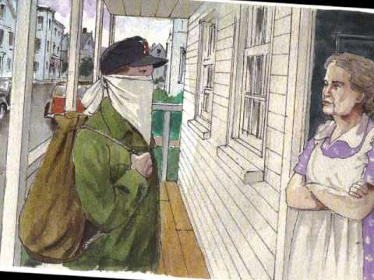

**Wider home learning activities**

* If you are interested in the historical events on which Heroes is based, you may enjoy the film, Pearl Harbour.
* ‘Hard Times’ by Stud Terkel is a book of words straight from the mouths of Great Depression survivors, from poor farmers to major political players.

**Character tracker -** Jot down a brief profile for each of the characters you meet:

Francis Cassavant

Nicole Renard

Larry LaSalle

Arthur Rivier

Mrs Belander

Enrico Rucelli

**Themes**

The novel has a very complicated outlook on heroism and what defines a hero. Francis is considered to be a hero as his actions during the war saved the lives of others, but the reader is asked to consider if cowardly actions can result in heroic consequences.

The ramifications of war are explored within the text, arguably with the trauma inflicted upon Nicole & Francis by Larry LaSalle representing the way war pays no regard to its effect on people, especially the young.

Religion is also a key theme as Francis is a devoted Catholic. The place of religion within the community of Frenchtown is often emphasised and the values instilled through his Catholic upbringing affects the decisions that Francis makes throughout his life. He also doesn't acknowledge that he is a hero he says that he was just there.

**Depression** -Many of the flashbacks in the novel refer to the Great Depression which was an effect of the Wall Street Crash of 1929. Many families then were poor and underfed. in 1932, Franklin Roosevelt was elected. He began the New Deal, which aimed to solve some of the problems within the country, such as unemployment. One of the schemes was for the government to employ people. This is seen in chapter 5 where Francis talks about people, renovating the 'Wreck Centre', who had been hired under a new municipal program.

**Second World War** -On 7 December 1941, the Japanese Empire carried out through the attack on Pearl Harbor, a Hawaiian island. The US then came into the Second World War taking them out of the policy of isolationism. Fighting occurs both in Europe, where Francis is deployed, and in the Pacific. The novel explores the effects of Pearl Harbor on Frenchtown, as the Wreck Centre closes because of Larry's absence. Many men are recruited to the armed forces, and women are given service jobs in the local factories to make products for the war effort.

**The GI** -The GI Bill is mentioned in the text in regards to the later plans of the veterans, which they discuss in the St Jude Club. Joe LaFontaine speaks about how the government would be willing to pay for his college education and intends to become a teacher. However, the positive outlook is shown to be false, as the veterans are later presented as pessimistic people, especially Arthur Rivier, who struggles to cope with not talking about the war.

**Setting**

Heroes is set in Frenchtown, a small town based upon Robert Cormier’s home of Leominster in Massachusetts. Much of the story is related in flashbacks to incidents that happened in 1940 and 1941. The main action of the novel takes place after the end of the Second World War in 1945.

**Key Vocabulary**

Retribution Vengeance Impassive Retaliation

Strife Protagonist Antagonist Rectitude

Duplicity (duplicitous)