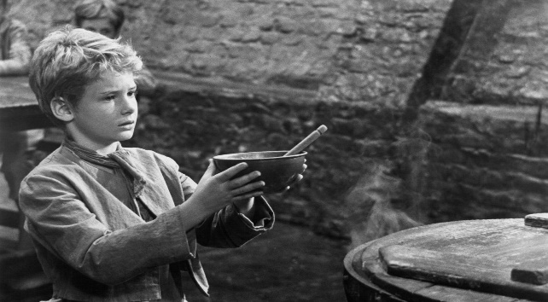

**Key Vocabulary**

Pernicious Felonious Immoral

Illegal Irresponsible Poverty Voracious

**Did you know?**

*The 1968 musical film Oliver Twist! won five academy awards including Best Picture!*

**Did you know?**

*Nancy’s murder is based on a real Victorian Murder before Jack the Ripper, called the Grimwood murder in 1838!*

**Additional Home Learning Tasks**

-Write a letter of apology from Sikes to Nancy for his regrettable actions.

-Write a review of the book focusing on the plot, key characters, best bits and recommendations.

**5 Minute Morphology!**

**‘anthropy’** is a **word element** meaning **‘relating to humankind’**. Which **prefixes** or **suffixes** can you add to create words relating to Oliver Twist? Can you make links to any scientific words?

Look at the **prefixes ‘im’** **‘il’ ‘ir’** in keywords **immoral**, **illegal and irresponsible.** Based on your understanding of these words, what might the prefix translate to? Once you know, find some that mean the opposite!

**Context**

Charles Dickens clearly understood the poverty in London during the 1800s, as he himself was a child worker after his father was sent to debtors’ prison. His appreciation of the hardships suffered by impoverished citizens stayed with him for the rest of his life and was evident in his writing. Dickens began writing Oliver Twist after the adoption of the [Poor Law of 1834](https://www.britannica.com/event/Poor-Law), which stopped government payments to the able-bodied poor unless they entered workhouses. Therefore, Oliver Twist became a story clearly aimed directly at the problem of poverty in 19th-century London.

**Links for further contextual research:** <https://owlcation.com/humanities/Charles-Dickens-and-Oliver-Twist-a-Social-History>

<https://www.coursehero.com/lit/Oliver-Twist/context/>

**Books for wider reading:**

The World of Charles Dickens: The Life, Times and Works of the Great Novelist

**Another Dickens’ novel to try**: Great Expectations

* Gr

**Key Quotes Challenge**

‘Please, ____ , I want some ______.’

‘What a fine thing _________ punishment is!’

‘You’d like to make pocket handkerchiefs as easily as the _________ Dodger wouldn’t you my dear?’

**Plot Summary**

Oliver Twist is born in a workhouse in 1830s England. He is transferred to a workhouse for adults after 9 years. After the other boys bully Oliver into asking for more gruel at the end of a meal, Mr. Bumble, the parish beadle, offers five pounds to anyone who will take the boy away from the workhouse. He is eventually apprenticed to a local undertaker, Mr. Sowerberry. Desperate, Oliver runs away at dawn and travels toward London.

Outside London, Oliver meets Jack Dawkins. Jack offers him shelter in the London house of his benefactor, Fagin. It turns out that Fagin is a career criminal who trains orphan boys to pick pockets. After a few days of training, Oliver is sent on a pickpocketing mission with two other boys. When he sees them swipe a handkerchief from an elderly gentleman, Oliver is horrified and runs off. He is caught by the police.

Mr Brownlow understands his innocence and tries to help Oliver, but he is kidnapped by Sikes and returns back to Fagin’s lair. Sikes’ girlfriend, Nancy, realises that Fagin wants Oliver for his inheritance (with the help of a man named Monks) and sees that she must set things right. She meets with Mr Brownlow and explains that Oliver is in danger. When word of Nancy’s disclosure reaches Sikes, he brutally murders Nancy and flees London. Pursued by his guilty conscience and an angry mob, he hangs himself while trying to escape.

Mr. Brownlow confronts Monks and squeezes the truth about Oliver’s parentage from him. Monks has been pursuing Oliver all along in the hopes of ensuring that his half-brother is deprived of his share of the family inheritance. Mr. Brownlow forces Monks to sign over Oliver’s share to Oliver. Finally, Mr Brownlow adopts Oliver and he has a secure and comfortable home in the countryside.