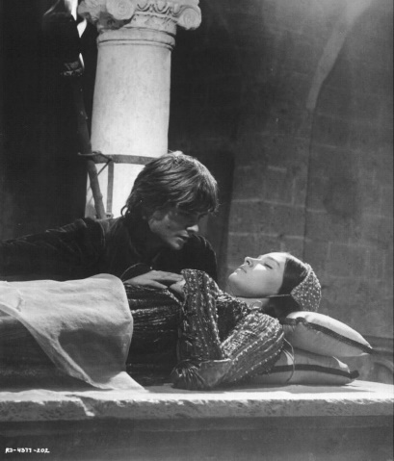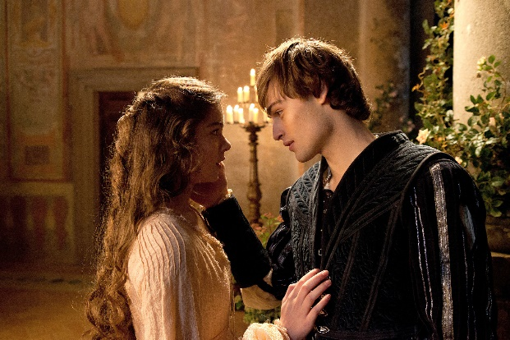

**Quiz questions!**

1. Where do Romeo and Juliet meet?
2. To what does Romeo first compare Juliet during the balcony scene?
3. To which city does Romeo go after being exiled from Verona?
4. To which powerful figure is Paris related?
5. Why is Romeo exiled?
6. Who performs Romeo and Juliet’s marriage?

**Further reading and home learning tasks**

* Research Elizabethan theatre and create a poster you would be likely to find in Shakespeare’s own theatre, the Globe.
* Create your own witty meme about the story of Romeo and Juliet – there are lots online!

**Did you know?**

In the Elizabethan Era, the father was the head of the household. Women had no rights or authority in law: they could not own property or money. Children were regarded as property and could be given in marriage to a suitable partner. This was often a political or financial transaction to secure and retain wealth. It was not unusual to be married very young.

In high society, children were often raised by a ‘wet nurse’ and did not have a strong bond

with their parents

**Plot Summary**

Two wealthy families, the Montagues and the Capulets, have another brawl in the city of Verona. The Prince and the townspeople cannot cope with the constant fighting so the Prince declares that the next person to break the peace will be killed.

Romeo Montague and his friends gatecrash a Capulet party and Romeo meets Juliet Capulet. He falls in love with her instantly. They are shocked to discover they are sworn enemies due to their feuding families. Friar Laurence marries Romeo and Juliet.

Romeo goes to celebrate his marriage with his friends, Mercutio and Benvolio, but gets into a fight with Juliet's cousin, Tybalt. Tybalt kills Mercutio and Romeo avenges his death by killing Tybalt. The Prince banishes Romeo because he killed Tybalt. Both Romeo and Juliet are heartbroken.

Capulet, Juliet's father, decides she should marry Paris. Juliet refuses and goes to Friar Laurence where they come up with a plan for Romeo and Juliet to be together.

What happens next? Wait and see!

**5 Minute Morphology!**

Contracted words are words in which a letter has been left out, which affects appearance and pronunciation. Shakespeare often used contracted words in order to fit his meter and rhyme scheme. If you see that apostrophe mark, it almost always means a letter is missing. Look out for these words, and any more you can spot, in Romeo and Juliet:

Be’t = be it Do’t = do it Know’st = know it

‘Tis = it is O’er = over

**Did you know?**

*The most famous line in the play has confused readers for centuries! Perhaps the most famous line in the play is spoken by Juliet: ‘Romeo, Romeo, wherefore art thou Romeo?’ Of course, ‘wherefore’ doesn’t mean ‘where’ – it means ‘why’. The question still doesn’t appear to make any sense: Romeo’s problem isn’t his first name, but his family name, Montague!*

**Key Vocabulary**

Allegiance Devotion Irrational Feud

Obedient Rivalry Patriarchal (society)

Unrequited

**Context**

It is generally believed that the play is based on a real Italian love story from the 3rd Century. The ‘real families’ are the Capeletti and the Montecci families. Shakespeare wrote his version in 1594 which was based on Arthur Brooke’s poem of 1562. This period was ‘The Elizabethan Era’ which was also known as ‘The Renaissance’: a time of significant change in the fields of religion, politics, science, language and the arts. Romeo and Juliet was set during a time of religious and political turmoil. Europe was a traditionally Catholic society with a strong belief in damnation for mortal sin.

Suicide and bigamy were both considered to be mortal sins.